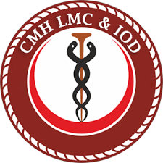
Study Guide
1st Year MBBS
(2025-2026)

Table of Contents
Introduction to Study Guide 4
Vision of National University of Medical Sciences 5
Mission of National University of Medical Sciences 5
Vision of CMH Lahore Medical College and Institute of Dentistry 5
Mission of CMH Lahore Medical College and Institute of Dentistry 5
Rationale of Curriculum 6
Curriculum Perspective 6
Introduction to Curricular Framework 6
Undergraduate Competencies 7
Yearly Outcomes 7
Exit Learning Outcomes of the MBBS program 8
Subjects for 2nd Year MBBS 9
Student Led Integrated Seminar Based on Themes 10
Contact Hours Distribution 11
Teaching and Learning Methods 12
Assessment Plan 12
Evaluation of the Course: 13
Online Learning & Assessment 13
System Maintenance & Confidentiality 14
Academic Calendar – 1st Year MBBS Session (2025-26) 15
Yearly Curriculum Committee 1st Year MBBS 2025-26 16
CMH Lahore Medical College – Policies 17
Contents of Block I Module I (Foundation I) 18
Contents of Block I Module II (Cell Structure & Function) 20
Contents of Block I Module III (Musculoskeletal System) 38
Contents of Block II Module V (Cardiovascular System) 53
Contents of Block III Module VI (Respiratory System) 96
Contents of Block III Module VII (Musculoskeletal System II) 110
Research Methodology Course Outline 117
Islamic Studies 119
Teaching of Holy Quran 122
Clinical Photography and Videography 124
Functional English 128
Expository Writing 130
Strategies For Enhanced And Advanced Learning (SEAL) 133
Learning Resources 137
Study Tips 141
Final Remarks 142
References 143
Feedback 143

Introduction to Study Guide
Congratulations and welcome to medical school! You should be incredibly proud of yourself for making it this far. In just a few years, you’ll be caring for real patients and making a real difference in their lives. It may feel overwhelming right now but trust us - it will be worth it.
Every big journey starts with a first step, and this is yours. This study guide is here to help you along the way. It has been created through a joint effort of faculty members and student representatives to give you a clear and helpful overview of the curriculum, in line with the guidelines of the Pakistan Medical & Dental Council and the National University of Medical Sciences.
The purpose of this guide is to support you in becoming an independent, lifelong learner. It gives you important information about your academic journey, including undergraduate competencies, learning outcomes, assessment methods, the curricular framework, academic calendar, online learning resources, relevant policies, and contact details of curriculum coordinators - all in one place.
To make learning more meaningful and easier to understand, subjects are horizontally integrated across the pre-clinical years. You’ll also experience early clinical exposure through lectures and integrated seminars, helping you connect what you learn in class with real-life medical practice.
At CMH Lahore Medical College, the focus goes beyond textbooks. The college is dedicated to improving community health by training students in preventive healthcare, health education, and community outreach. You’ll also learn important skills like leadership, management, and medical education through dedicated teaching hours in the curriculum.
Now it’s time to begin this exciting new chapter. Work hard, stay curious, support each other—and most importantly, enjoy the journey. We wish you all the very best for the years ahead!

School of Health Professions’ Education
CMH LMC & IOD


Image Source: Generated using OpenAI’s DALL·E.
This image is AI-generated and does not depict real individuals.
Used for educational purposes only

Vision of National University of Medical Sciences
To be the best medical university by conducting world-class bio-medical research and creative research activities that develop knowledge and contribute to improve the health care system and social advancement for the people of Pakistan and benefit humanity as a whole with a standard of excellence.

Mission of National University of Medical Sciences
Our mission is to emphasize rigorous research fundamentals while stimulating innovation and providing talented students and faculty with the high standard research facilities in the colleges/institutions of NUMS, necessary to achieve excellence in bio-medical research to contribute toward best care for our individuals and communities, embraces the challenges of health disparities and improve health care system up to international standards.

Vision of CMH Lahore Medical College and Institute of Dentistry
To be a leading institute in medical education that provides an inclusive and conducive environment to foster excellence in teaching, learning, acquisition of clinical skills, research, and innovation to improve future health indicators within our region and beyond.

Mission of CMH Lahore Medical College and Institute of Dentistry
To improve healthcare by:
- Providing quality medical education that prepares healthcare professionals according to internationally accepted benchmarks for empathy, social accountability, lifelong learning, critical thinking, and sound clinical acumen.
- Ensuring a conducive and equitable learning environment in research and continuous professional development for students and faculty respectively, enabling their success in national and international licensure examinations and opportunities.
- Fostering evidence-based and patient-centered care to efficiently address global healthcare challenges, focusing on prevention and community health improvement.

Rationale of Curriculum
This curriculum has been designed by NUMS to address both local and international needs. The curriculum is focused to prepare future doctors to treat local patients efficiently and safely employing best evidence clinical practice. There are many embedded opportunities for students to learn leadership in order to prepare them for their future role as a leader in a healthcare team. There are numerous opportunities for students to learn and practice leaderships skills by participating in integrated seminars, CPCs, clinical rotations and co-curricular activities. In order to give medical students requisite evidence-based practices health education, research module, research day and elective in preventive health education are added in the curriculum to ensure their holistic growth.

Curriculum Perspective
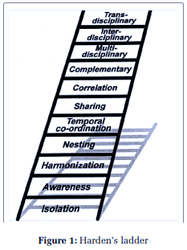
At CMH Lahore Medical and Dental College, the Curriculum has been developed along with specifications of Harden’s 7th level of integration. These curricular flavors provide opportunities to students to have structured learning and practice session along with information orientated feedback, small group learning, critical thinking, decision making and problem-solving opportunities.

Introduction to Curricular Framework
The implemented curriculum is at the 7th level in the integration ladder where basic sciences’ facts are correlated with clinical sciences through student led integrated seminar, skill labs and clinical visits.
- PHASE 1 (Year 1 and 2): Includes basic sciences namely, Anatomy, Physiology, and Biochemistry with horizontal integration within the basic sciences and vertical integration through integrated seminars and interactive lectures in Surgery, Medicine, and Behavioral Sciences.
- PHASE 2 (Years 3,4 & 5): Includes paraclinical and clinical sciences namely, Pharmacology, General Pathology, Special Pathology, Community Medicine, Forensic Medicine, Behavioral Sciences, Eye, ENT, Medicine, Psychiatry, Pediatrics, Surgery, and OBGYN, Internal Medicine, Gastroenterology, Rheumatology, Dermatology, Pulmonology, Cardiology, Nephrology, Endocrinology, General Surgery, Orthopedics. and Urology.

Undergraduate Competencies
CMH Lahore Medical College and Institute of Dentistry envisions training undergraduate students in following competencies:

Yearly Outcomes

Exit Learning Outcomes of the MBBS program
Exit learning outcomes describe what students are expected to know and be able to do by the time they graduate. They relate to skills, knowledge, attitudes, and professional behavior that students acquire as they progress through the program. At CMH Lahore Medical College and Institute of Dentistry, our goal is to train every graduating student in demonstrating requisite characteristics and skills that are needed for the 21st-century medical graduate. Exit outcomes are directly linked to the list of competencies and enabling outcomes of each subject being taught over a span of 5 years in the MBBS program.
On completion of MBBS program, you will be able to:

Subjects for 2nd Year MBBS
Core Subjects:
The following are the core subjects for 2nd year MBBS.

Integrated Subjects:
The following are the integrated clinical subjects for which regular periodic assessment will be done throughout the academic year and their attendance would be carried forward towards the year of examination of relevant subject.

Student Led Integrated Seminar Based on Themes
Integrated led Integrated Seminars are a vital component of the 1st year MBBS curriculum, designed to foster a comprehensive understanding of medical science by connecting various disciplines. These seminars are a collaborative effort between the departments of Anatomy, Physiology, Biochemistry, Surgery, Medicine, and Medical Education.
By connecting theoretical knowledge with clinical scenarios these sessions aim to develop a cohesive schema that prepares students for the complexities of healthcare practice.

Standard Operating Procedures (SOP) of Integrated Seminars
.
Through integrated sessions, students not only deepen their understanding of individual subjects but also learn to appreciate the interconnected nature of medical knowledge. By fostering collaboration, critical thinking, and effective communication, these sessions lay the foundation for lifelong learning and professional growth in the field of medicine.

Contact Hours Distribution

Subjects | Contact Hours
Anatomy | 250
Physiology | 225
Biochemistry | 125
Medicine & Allied | 50
Surgery & Allied | 40
Basic of Radiology | 15
Research Methodology & EBM | 10
Behavioural Sciences | 05
Communication Skills | 05
Leadership and Management | 05
Professionalism | 05
Quran Kareem | 25
Introduction to Computer | 25
Islamiyat | 25
Expository Writing | 25
Co-curricular activities/sports | 40
Clinical Photography & Videography OR Strategies for Enhanced and Advanced Learning | 25
Total Hours | 900

Teaching and Learning Methods
The teaching-learning will be through diverse methods and will include:

Assessment Plan
The assessment plan comprises 2-3 term tests, 1 send-up, and 1 professional examination. Examination consists of one-best multiple-choice questions and short essay type questions along with OSPE/OSCE. All exams except for University’s exam/professional exam contribute towards internal assessment of the respective subjects according to the institutional policy. The assessment schedule is given below
Type of Assessment | Weightage | Frequency and Time | Methods/ Tools for Assessment
Formative | - | Informally during and after the session. | Class tests (MCQs, SEQs), Class presentations, Assignments, Tutorials, Case Based Discussions, Team based learning, Portfolios
Summative | Internal assessment | 20% | 2-3 term tests (quarterly), Send up (before the professional exam) (80%) Attitude/ behavior/ attendance/ assignments/ achievements (throughout the year) (20%)
Summative | University exam | 80% | Once at the end of academic year

Annual Professional Examination (80% weightage)
  - The University will take second professional Examination at the end of the academic year.
  - There will be three papers (block-wise) of 150 marks each, with MCQs and SEQs/SAQs in 70:30 ratios.
  - Each theory paper has three sections of Anatomy, Physiology, and medical biochemistry with a total 40 Marks for each subject in each paper.
  - There will be 3 x Integrated Practical Exam and structured viva, block-wise, of 150 Marks each.
  - It is mandatory to secure minimum of 50% passing Marks, in theory & practical separately, in each Prof Exam. However, in theory, paper min. 40% Marks shall be secured in each subject, both theory and practical. The student will have to repeat the block-wise paper in which he/she secures less than 40% Marks in any section

Evaluation of the Course:
The major goals of the evaluation are to monitor quality of teaching and assessment and improve the implemented curriculums.
- Feedback through CMS will be taken at the end of block from students and faculty members.
- LQEC receives recommendation from Evaluation Committee compromising of
  - Head of QEC: Dr. Rizwana Kamran (Associate Professor SHaPE)
  - Officer 1: Dr. Hira Amar (Demonstrator SHaPE)
  - Any one student from each academic year.
  - Representation from each academic year.
- LQEC generates reports to be shared with the yearly curriculum and institutional curricular committee for implementation of recommendation from students and faculty members.

Online Learning & Assessment
The COVID-19 pandemic has transformed education, introduced new challenges while fostered innovation catering for the unforeseen situations: Now institutions within Pakistan and across the world are expected to be ready to resume online learning and assessment in times of emergency. The Learning Management System (LMS) at CMH LMC & IOD ensures that online education is standardized, interactive, and aligned with academic and professional requirements.

Switch over to online learning will be notified a day before or on the same day before the first academic session depending upon the nature of national emergency situation.

The LMS combines Moodle and Zoom, designed to meet the needs of students. Key features include:

  - Access to Courses: Students can view recorded lectures, access course materials, and engage with faculty.
  - Attendance Verification: Attendance is tracked using a dual system:
- Moodle login records.
- Mandatory quizzes after each lecture (not-graded).
  - Progress Monitoring: Regular assessments such as quizzes and assignments track students’ performance.

Feedback Mechanisms: Integrated evaluation forms enable students and faculty to provide input for continuous improvement.
To ensure privacy and security:
  - Students: Receive personalized logins to access course materials.
  - Faculty: Have permissions to upload content, grade assignments, and track student progress.
  - SHaPE & QEC: Monitor and evaluate LMS activities to monitor quality.
  - IT Support: Manage user accounts, system updates, and security.
Special access requests are managed through the CE Secretariat in consultation with the IT department. Assessments are designed to support learning and maintain academic rigor:
  - Formative Assessments: Quizzes and assignments contribute to assessment for learning but do not count toward final grades.
  - Summative Assessments: Online term exams and send-ups.
  - Feedback and Quality Assurance: Student evaluations collected through QEC proformas ensure ongoing improvement of online teaching practices.

System Maintenance & Confidentiality
  - Planned Outages: The IT department notifies users in advance of any maintenance.
  - Privacy Policies: All users are accordingly notified to must comply with institutional and PMDC regulations to protect intellectual property and personal information.
  - Security: The IT team monitors and manages unauthorized access or inappropriate behaviors.

Roles and Responsibilities

User Role | Permissions
Students | Access lectures, take quizzes, and submit assignments.
Instructors | Upload course content, grade assignments, and track students’ performance.
SHaPE & QEC | Review course quality, quizzes, assignments, and suggest modifications accordingly.
IT Department | Manage user accounts, add or remove courses, and deploy updates.

Academic Calendar – 1st Year MBBS Session (2025-26)
Weeks | Details | Dates
Weeks | Details | From | To
Block I (02+07+05+01=15 weeks)
01 | Start of New Class | 16 Feb 2026
01 | Orientation Week  Academic Classes Block I  Module I (Foundation I) (01 wks) | 16 Feb 2026 – 20 Feb 2026
2-5 | Academic Classes Block I (04 weeks)  Module I (Foundation I) (01 wks)  Module II (Cell Structure and Functions) (3/7 wks) | 23 Feb 2026 | 19 Mar 2026
2-5 | Eid ul Fitr (Tentative) | 20 Mar 2026 | 22 Mar 2026
6 | Pakistan Day | 23 March 2026
6 | Spring Vacations | 24 Mar 2026 |  | 27 Mar 2026
7-15 | Academic Classes Block I (09 weeks)  Module II (Cell Structure and Functions) (4/7 wks)  Module III (MSK-1) (5 wks) | 30 Mar 2026 |  | 26 May 2026
7-15 | Labor Day | 01 May 2026
7-15 | Nawa e Sarosh (CMH Literary Festival) | 13 May 2026
7-15 | Annual Sports Day | 20 May 2026
7-15 | Eid ul Azha (Tentative) | 27-29 May 2026
16-19 | Summer Vacations (4x weeks) | 01 June 2026 |  | 26 June 2026
16-19 | Ashura (Tentative) | 24 -25 June 2026
20 | Block I Exam (1 Week)  (Date Sheet will be finalized by IEC in YCC meeting) | 29 June 2026 |  | 03 July 2026
 | Life-line Symposium | 01 July 2026
Block II (09+01=10 weeks)
21-29 | Academic Classes Block II (09 weeks)  Module I (Cardiovascular System- I) (09 wks) | 06 July 2026 | 04 Sep 2026
21-29 | Annual GK Quiz Competition | 07 July 2026
21-29 | Irteqa | 09 July 2026
21-29 | Purpose Over Popularity | 15 July 2026
21-29 | Olympiad | 17 July 2026
21-29 | Trifecta (Opening Ceremony) | 24 July 2026
 | Trifecta (Closing Ceremony) | 26 July 2026
 | Annual Research Conference | 30 July 2026
 | Inter Med Fest | 03 Aug 2026
 | Independence Day Event | 13 Aug 2026
 | Independence Day | 14 Aug 2026
 | Qiraat & Naat Competition | 20 Aug 2026
 | Eid Milad-un-Nabi | 25 Aug 2026
30 | Block II Exam (1 Week)  (Date Sheet will be finalized by IEC in YCC meeting) | 07 Sep 2026 | 11 Sept 2026
Block III (04+05+01=10 weeks)
31-39 | Academic Classes Block III (09 weeks)  Module I (Respiratory System- I) (04 wks)  Module II (MSK-1I) (05 wks) | 14 Sept 2026 | 13 Nov 2026
40 | Block III Exam (Written) | 16 Nov 2026
40 | Pre-Annual/ Send-up Leave | 17 Nov 2026 | 20 Nov 2026
41-42 | Pre-Annual/ Send-up Exam (Theory + OSPE)  (Date Sheet will be finalized by IEC in YCC meeting) | 23 Nov 2026 | 02 Dec 2026
43-45 | Prep Leave Annual Exam | 03 Dec 2026 | 25 Dec 2026
 | NUMS Annual Professional Exam | 28 Dec 2026

Yearly Curriculum Committee 1st Year MBBS 2025-26
Name | Department | Extension No | Designation
Prof. Dr. Ansa Rabia | Anatomy | 490 | Convener First Year MBBS, HOD & Professor
Prof. Dr. Ambreen Tauseef | Physiology | 460 | HOD & Professor
Prof. Dr. Huma Sultan | Biochemistry | 500 | HOD & Professor
Prof. Dr. Imran Hameed Daula | Surgery | 453 | Professor
Dr. Irum Mansoor | Behavioral Sciences | 446 | Associate Professor
Dr. Shireen Rafique | Community Medicine | 457 | Associate Professor
Dr. Saba Saif | Medicine | — | Assistant Professor
Dr. Rizwana Kamran | SHaPE | 436 | Assosciate Professor
Ms. Noor | English | — | Assistant Professor
Mr. Bakhtawar Ali | Islamiyat | — | Lecturer
Student Representation | — | — | CR, GR & MCR

CMH Lahore Medical College – Policies
- Attendance and disciplinary policy https://cmhlahore.edu.pk/wp-content/uploads/2024/10/std-policy.pdf
- Policy for Steering Committee for the Selection of Class Representatives (BR and GR) Based on Student Feedback https://cmhlahore.edu.pk/wp-content/uploads/2025/01/Steering-committee.pdf
- Social Media Policy for Faculty, Staff, and Students https://cmhlahore.edu.pk/wp- content/uploads/2024/02/Social-Media-Policy-for-students-02-08-2023.pdf
- Internet Usage Policy https://cmhlahore.edu.pk/wp-content/uploads/2023/09/CMH-Internet-Usage-Policy-02-08-2023.pdf
- Healthcare Facility https://cmhlahore.edu.pk/wp-content/uploads/2023/09/Health-Care-Facility.pdf
- Complaint Cell https://cmhlahore.edu.pk/wp-content/uploads/2023/09/Complaint-Cell-CMH-LMC-IOD.pdf
- SOP for Online Teaching Backup Plan https://cmhlahore.edu.pk/wp-content/uploads/2025/11/online-teaching-backup.jpeg
- Drug and tobacco abuse/smoking https://cmhlahore.edu.pk/wp-content/uploads/2022/11/SOP-Drug-and-Tobacco.pdf
- Grievance Policy https://cmhlahore.edu.pk/wp-content/uploads/2025/10/DOC-20251028-WA0237.pdf
- Disciplinary Committee Policy https://cmhlahore.edu.pk/wp-content/uploads/2025/05/SOP-Disciplinary-Committee-CMH-LMC-IOD.pdf
- Co-curricular Activities https://cmhlahore.edu.pk/wp-content/uploads/2022/11/Co-curricular-privacy-policy.pdf
- Elective Policy https://cmhlahore.edu.pk/wp-content/uploads/2022/11/electives-policy.pdf
- CMH LMC Formative Assessment and Feedback Policy https://cmhlahore.edu.pk/wp-content/uploads/2022/11/CMH-LMC-Formative-Assessment-and-Feedback-Policy.pdf
- Anti-Harassment Policy for Students https://cmhlahore.edu.pk/wp-content/uploads/2025/10/Anti-Harrasment-policy-for-website.pdf
- Infection Control SOP’s https://cmhlahore.edu.pk/wp-content/uploads/2025/05/Infection-Control-Protocol-SOP-1-30.pdf
- Attendance and Disciplinary Policy https://cmhlahore.edu.pk/wp-content/uploads/2024/10/std-policy.pdf
- NUMS policy on Diversity, Equity and Inclusion https://cmhlahore.edu.pk/wp-content/uploads/2025/07/NUMS-Policy-on-DiversityEquity-and-Inclusion.pdf

Introduction
A medical doctor is expected to understand and uphold the values and principles of medical profession, along with practical aspects of clinical practice and patient care. The MBBS program therefor, shall focus on developing the knowledge, skills, and attitudes required to become a competent and ethical healthcare professional, with a strong sense of professional identity and commitment to lifelong learning
Entrants in medical colleges came from diverse background and these students may face maladjustment. It is therefore necessary to develop and implement students’ orientation program at the entry level of MBBS program to acclimatize them to campus environment, familiarize with teaching programs, help adapt to the academic challenges as they move from high school into undergraduate programs.
This module would help students coming from a very different learning environment to cope with the vast body of knowledge and skills that are required in the dynamic and rapidly changing health-care system.

Contents of Block I Module I (Foundation I)

MBBS YEAR I
BLOCK I
MODULE I
FOUNDATION I
DURATION: 02 WEEKS



Learning outcomes | Learning Objectives/ Content | Instructional strategies | Assessment tool
At the end of this module, students will be able to:
    Recognize the history and importance of medicine as a profession. | - Recognize the importance of Medicine in human life  - Understand the evolution of modern medicine | Lecture | -
Recognize the role of different disciplines in studying the human body | Comprehend different medical disciplines, departments and faculty | Lecture | -
Acknowledge the interdisciplinary nature of medical education and practice | Comprehend the basic concepts of Physiology, Anatomy, Biochemistry and clinical subjects | Lecture | -
Develop a sense of professional identity. | Identify themselves as a part of new community of practice | White coat ceremony | Self-assessment through feedback  proformas
Develop a sense of professional identity. | Relate the personal experiences and their impact on personal and professional identity formation | Small Group Discussion/ Concept Map | Formative
Analyze the importance of ethics and professionalism in medicine | Apply the ethical boundaries of conduct as a student | Small Group Discussion | Formative
 | Comprehend the importance of professionalism for medical doctor | Small Group Discussion | Formative
Enhance their English language skills | - Improve communication skills in English, with a specific focus on medical terminology and effective patient-doctor interactions.  - Exhibit a more comprehensive command of the English language to facilitate clear and accurate  medical communication. | Small Group Discussion | Essay/ Assignments
Appreciate the significance of green initiatives in healthcare and identify ways to contribute to sustainability. | - Cultivate an understanding of sustainability and environmental consciousness in the context of healthcare.  - Recognize and promote eco- friendly practices in medical settings, such as reducing waste, conserving resources, and minimizing the carbon footprint. | Small Group Discussion | Formative

Contents of Block I Module II (Cell Structure & Function)
MBBS YEAR I
BLOCK I
MODULE II
CELL STRUCTURE & FUNCTION
DURATION: 07 WEEKS

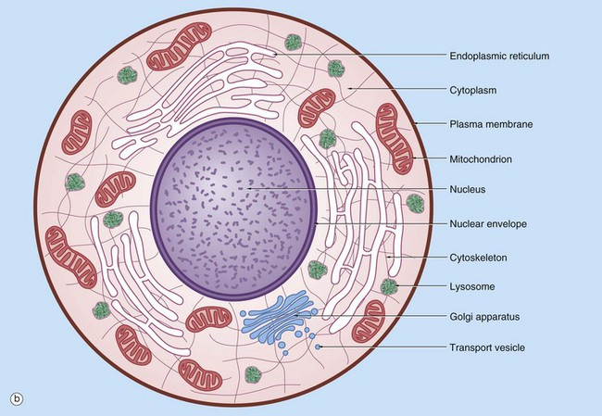
ACCD
Integration of Disciplines

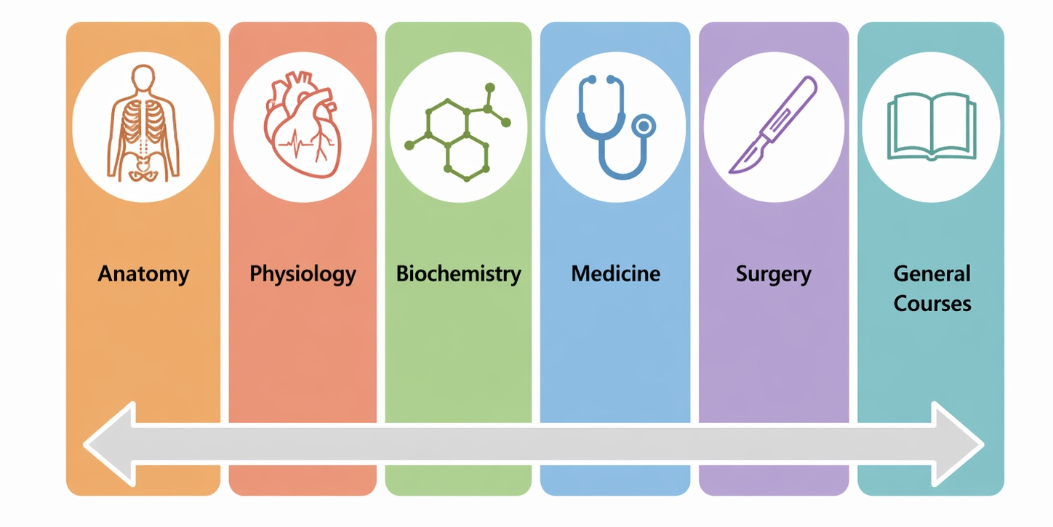

MODULE PLANNING COMMITTEE

Block Coordinator | Dr. Rabia Latif (Anatomy Department)
Module Coordinator+  Members | Anatomy: Dr Tayyaba Mahmud, Dr Shamir A Khan, Dr. Raffia Irfan \  Physiology: Dr. Amna Nadeem, Dr. Amna Quddus, Dr. Faiza Habib, Dr. Ujala Ali, Dr. Jaweria Muhamad  Biochemistry: Dr. Hira Saeed, Dr. Faiza Ahmed, Dr/ Maham Zulfiqar, Dr. Adeeba Fatima, Dr. Abida Asghar

Learning outcomes:
By the end of this module, students will be able to integrate embryological, histomorphological, physiological, and biochemical knowledge to analyze the structure and function of cells, blood components, and appraise the clinical aspects of their dysfunctions

Learning Outcomes | Subject Learning Outcomes | Teaching & Learning Strategies | Proposed Assessment Strategies
By the end of the session, students should be able to; |  | Teaching & Learning Strategies | Proposed Assessment Strategies
Cellular Basis of Health and Disease
Analyze cellular structures and their  physiological and  biochemical roles to  understand their  clinical significance | Anatomy Introduction  - Demonstrate the anatomical position  - Name various planes of the body  - Define the terms of position, movement, and laterality  - Correlate microscopic structure of cytoskeleton with variation in cellular modifications  General Histology Cell  - List various cell organelles along with their functions  - Explain the structure and functions of various components of cytoskeleton  Epithelial tissue  - Define epithelium  - Classify epithelium with examples of each type  - Classify Glands with examples.  - Define polarity  - Differentiate among various epithelial cells  - List the structural modifications of apical, lateral and basal domains of the cell.  - Classify the apical modifications according to motility  - Name the component of cytoskeleton contributing in each apical modification  - Define metaplasia and correlate it with its clinical importance.  - Classify various types of cell junctions according to functions, providing examples of each.  General Embryology Gametogenesis  - Explain the sequence of events of mitosis and meiosis with the help of illustrations and models.  - Elucidate the morphological changes in male and female gametes during their maturation  Define the following terms in relation to spermatogenesis and oogenesis:  - Haploid  - Diploid  - Euploid | SGD, LGIS & CBL | MCQs, SAQs, SEQs, OSPE, Structured Viva

Physiology
- Describe the parameters needed for the control of the ‘internal environment’
- Differentiate between the intracellular and extracellular fluid compartments
- List the typical value and normal range for plasma Na+, K+, H+(pH), HCO3-, Cl-, Ca2+, and glucose, and the typical intracellular pH and concentrations of Na+, K+, Cl-
- , Ca2+, and HCO3-
- Explain Homeostasis and the factors that are regulated through homeostasis
- Recognize the interplay of various organ systems in maintaining homeostasis
- Compare and contrast positive, negative and feed forward feedback mechanisms as the control systems of the body.
- Narrate examples of each feedback control system
- Discuss the outcomes of failure of the feedback control system of homeostasis
Cell Organelle
- Discuss the functional organization of human body
- Differentiate membranous organelles from non- membranous organelles
- Restate the structure & function of nucleus, nuclear membrane, Chromatin & Chromosomes, Nucleoplasm & Nucleolus
- Compare the structure & function of smooth endoplasmic reticulum & RER
- Appreciate the importance of Golgi apparatus in packaging and storage of newly formed proteins
- Discuss the structure & functions of vaults
- Discuss the synthesis, types & functions of ribosomes
- Summarize the structure & functions of secretory vesicles
- Discuss the physiological anatomy of mitochondria &
- discuss its functions in special relation to energy synthesis.

- Compare and contrast the functions of lysosomes & peroxisomes
Cytoskeleton and cell locomotion
- Discuss the structure & function of cell cytoskeleton (microtubules, microfilaments & intermediate filaments)
- Recall movements of cells (amoeboid, ciliary & flagellar movements)
Genetic Control of cell function
- Comprehend Genetic control of cell functions and cell division
Cell membrane
- Describe the composition of a human cell membrane
- Diagram its cross section, and explain how the distribution of phospholipids and proteins influences the membrane permeability of ions, hydrophilic and hydrophobic compounds
- Enlist the various functions of integral and peripheral proteins in the cell membrane
Transport of substances through cell membrane
- Classify various modes of transport of substances across the cell-membrane
- Compare and contrast amongst the processes of osmosis, diffusion & facilitated diffusion (transport of micro molecules)
- Compare and contrast the process of exocytosis & endocytosis (transport of macromolecules)
Active Transport of substances through membranes
- Explain the process of primary active transport with examples
- Give an account on the structure, working and important functions of Na+ / K+ pump
- Enlist other active transport pumps present in human body e.g. sarcoplasmic reticulum Ca2+ pump, and gastric H+ pump
- Grasp concept of Secondary active transport.

- Differentiate co-transport & counter-transport with examples
- Describe how energy from ATP hydrolysis is used to transport ions such as Na+, K+, Ca2+, and H+ against their electrochemical differences (e.g., via the Na+ / K+ pump,)
MEDICAL BIOCHEMISTRY
- Identify the basic elements of biochemistry and the significance of the Human Genome Project
- Elaborate various biomolecules and their roles in cellular function
- Discuss the fluid mosaic model
- Discuss the biochemical composition and functions of the components of cell membrane
- Compare the biochemical significance of different types of membranes, including:
  - RBCs
  - Mitochondria
  - Nucleus
  - Endoplasmic reticulum
  - Golgi apparatus
- Explain the biochemical composition and functions and marker enzymes of various cell organelles, including:
  - Nucleus
  - Ribosomes
  - Peroxisomes
  - Mitochondria
  - Golgi apparatus
  - Endoplasmic reticulum
  - Endosomes
  - Lysosomes
- Describe the chemistry of cell surface receptors and the associated signaling mechanisms
- Describe the chemistry of intracellular receptors and the related signaling mechanisms
- Compare the biochemical basis of various membrane transport mechanisms, including:
  - GLUTs
  - SGLT
  - Carnitine shuttle
  - H/K ATPase pump

- Cl ion channels
- Malate shuttle
- Receptor-mediated endocytosis
- Aquaporin
- ATP-sensitive K Channel

Enzymes:
- Classify enzymes in the context of medical biochemistry
- Outline the mechanism of enzyme action
- Explain the components of enzymes (apoenzyme, holoenzyme, coenzyme, cofactor, and prosthetic group and isoenzymes) and their biochemical significance
- Describe the factors that affect enzyme activity
- Define the Michaelis-Menten equation and the Lineweaver-Burk plot, along with their applications in enzyme kinetics (without deriving the equations)
- Compare and contrast different types of enzyme inhibition, providing examples and discussing their biomedical significance
- Explain the concept of regulatory enzymes
- Explain the biochemical role of isoenzymes in clinical enzymology and their significance in disease diagnosis and treatment
- Provide an overview of the role of minerals as cofactors
- Give an overview of the role of vitamins as coenzymes,
- focusing on B1, B2, B3, B6, biotin, and pantothenic acid
 | Clinical Relevance | Integrated
 | Chromosomal Aberrations:  - List numerical and structural chromosomal disorders  - Aneuploid  - Triploid  - Polyploid  - Nondisjunction  - Monosomy  - Trisomy  - Mosaicism  - Translocation | sessions/CBL/ LGIS
 | - Explain the embryological basis and clinical presentation
of following syndromes:
- Down’s
- Kleinfelter
- Turner
- Angelman
- Pradar Willi
- Cri du chat

- Compare & contrast apoptosis & necrosis
- Explain the pathophysiology of cancer and aging (General disorders), polycystic kidney disease.
- Recognize the cause of Kartagener syndrome
- Apply biochemical functions of cellular biomarkers in clinical context
- Correlate associated disorders of various cell organelles:
- Endoplasmic Reticulum (ER):
  - Cystic Fibrosis
  - Non-Alcoholic Fatty Liver Disease (NAFLD)
- Lysosomes:
  - Gaucher Disease
  - Tay-Sachs Disease
- Peroxisomes:
  - Zellweger Syndrome
- Plasma Membrane:
  - Hereditary Spherocytosis
  - Familial Hypercholesterolemia
- Cytoskeleton:
  - Duchenne Muscular Dystrophy
- CytoplasmicInclusions:
  - Parkinson's Disease
- Elaborate the role of signal transduction in health and disease
- Elaborate the role of membrane transport mechanisms in health and disease:
  - Cholera
  - Pertussis
  - Cystic Fibrosis
- Comprehend the clinical significance of Monosaccharides, disaccharides and Polysaccharides: Sorbitol, Mannitol, Inulin, Dextran, Hyaluronic acid & Heparin
- Discuss Porphyrias
- Discuss Hyperbilirubinemia and jaundice
- Overview of Role of Iron, Vit B9 & B12 in Nutritional Anemia
- Overview of role of Vitamin C & K in bleeding disorders

RBC - Pallor/ Jaundice

Describe the developmental events during first, second and third weeks of development | Anatomy Embryology  Ovulation, Fertilization, development 1st week  - Correlate the menstrual and ovarian cycles with each other  - Describe the process of ovulation  - Define corpus luteum and corpus albicans  - Define fertilization.  - Describe and illustrate the steps, and outcomes of fertilization  - Describe the basic principles behind various techniques of in vitro fertilization  - Describe the process of implantation.  - List the sites of abnormal implantation and describe their clinical significance.  - Define cleavage, morula, blastula  - Identify the various phases of development on the given model  Second week of Development  - Explain the events of second week of development in a sequence  - Justify the statement that the second week is known as “week of two’s  Enumerate the sequential phases of human development during third week  - Define Gastrulation  - Describe the formation of notochord and the establishment of body axes.  - Recognize the embryological basis of sacrococcygeal teratoma, Holoprosencephaly, caudal dysgenesis, Situs inversus  Skill:  Identify the various phenomenon during first, second and third weeks of development on the given model and diagrams | SGD, LGIS & CBL | MCQs, SAQs, SEQs, OSPE,  Structured Viva
Embryonic period (Third to Eight Weeks). | - Enlist derivatives of Surface ectoderm, Neuroectoderm, Neural crest, Intraembryonic mesoderm (paraxial, intermediate, lateral plate), Endoderm  - Explain somitogenesis and differentiation of somites  - Explain the development of Intraembryonic coelom. | LGIS | MCQs/ SEQs/ SAQs/ OSPE/ VIVA VOCE.

- Correlate the folding of the embryo in the horizontal and longitudinal planes with its consequences.
- Explain the processes of formation of blood vessels
- Define hemangioma and explain its embryological basis
- Correlate the developmental events during the embryonic period with relevant congenital anomalies
- Define neurulation and describe process of formation
of neural plate, neural tube and neural crest cells
Integrate | Physiology  Composition & Functions of blood  - Make a flow sheet diagram of cellular and fluid composition and general functions of blood.  Erythropoisis in bone marrow  - Enlist sites of hemopoiesis in the body during different stages of life.  - Make a flow sheet diagram of various stages of erythrogenesis with explanation of their relevant features and sizes during different stages of differentiation of RBC’s.  - Enlist different growth & differentiation inducers involved in erythropoiesis  - Identify the factors in regulation of erythropoiesis and maturation of RBC with relative importance of hypoxia in inducing erythropoiesis.  - Appreciate the role of erythropoietin in regulating RBC production.  - Discuss the role of vitamin B12 & folic acid in maturation of RBC | SGD, LGIS & | MCQs,
physiological and |  | CBL | SAQs, SEQs,
Biochemical |  |  | OSPE,
knowledge of red |  |  | Structured
blood cells to analyze |  |  | Viva
relevant clinical |  |  | Viva
Disorders
 | Clinical Relevance Anemia & Polycythemia  - Classify anemia based on their morphological findings, RBC indices & etiology.  - Compare and contrast different types of anemia on the basis of etiology, clinical presentations and blood picture.  - Explain the effect of anemia on circulatory system.  - Classify polycythemia into primary and secondary polycythemia and discuss its effects on circulatory system.  - Describe etiology, pathophysiology and clinical presentation of polycythemia | Integrated
 |  | sessions/CBL
 |  | /LGIS

Inflammation & Immunity – Leucocytosis/ Leucopenia
Correlate the | Anatomy  - Comprehend general concept of structure of skin, fascia, bones, muscles and joints  Histology - Connective tissues  - List the components of connective tissue.  - List various CT cells and fibers  - Classify connective tissue  - Describe the characteristic features of each type  - Explain the role of fibroblasts in wound contraction  - Elucidate the role of macrophages in defense | SGD, LGIS & | MCQs,
histological, and |  | CBL | SAQs, SEQs,
physiological |  |  | OSPE,
knowledge of white |  |  | Structured
blood cells and |  |  | Viva
cytokines with their |  |  | Viva
clinical significance
Physiology
WBC- Morphology
- Enlist different types of white blood cells and discuss their physiological characteristics.
- Define the terms: leukopenia, leukocytosis
- Neutrophila, neutropenia, eosinophilia, eosionpenia, Basophilia & basopenia.
- Make a flow sheet diagram showing steps involved in leukopoiesis.
- Enlist the factors necessary for leukopoiesis.
- Describe the role and functions of white blood cells in providing protection to the body against invading organism.
- Demonstrate proficiency in preparing and staining blood films for the identification of white blood cell (WBC) morphology.
- Identify morphological features of various types of WBCs for identification.
Innate immunity + complement system
- Define innate immunity. Discuss the mechanisms involved in innate immunity.
- Comprehend basis of innate immune system of the body and tissues related with innate immunity.
- Discuss the role of natural killer cells & interferons in innate immunity.
- Identify the specific role of interferons against virus infected cells and discuss their mechanism of action
Monocyte-macrophage system
Appraise the composition and functions of reticulo endothelial system.

Line of defense against infection & phagocytosis

- Explain the lines of defense against infection: role of neutrophils & macrophages.
- Discuss the role of eosinophils & basophils.
Inflammation
- Define inflammation.
- Discuss causes, cellular features and five cardinal signs of inflammation.
- Explain the process of inflammation.
- Give an account on process of “walling-off” involved in inflammation.
- Describe pathophysiology of necrosis
General concept of T & B lymphocytes. Active & passive immunity
- Enlist the types of immunity.
- Discuss the mechanism involved in development of immunity. Discuss the processing of T & B lymphocytes in human body.
- Give a brief account on lymphocyte cloning.
- Define immunization & enlist its types.
- Discuss the role of memory cells involved in the process of immunization.
- Compare & contrast active and passive immunity.
- Describe the physiological basis of vaccination.
B-cell immunity
- Comprehend the concept of humoral immunity.
- Discuss the structure of antibodies.
- Classify antibodies. Discuss their functions.
- Explain the role of antibodies in B-cell immunity
Mechanisms of action of antibodies
- Discuss the mechanisms through which antibodies directly attack an invading agent.
- Give an account on the indirect action of antibodies on invading agent through complement system.
- Enlist the various complement proteins and their functions.
Allergy /Hypersensitivity
- Explain different types of allergy.
- Discuss the mechanism involved in development of an allergy & hypersensitivity.

- Explain the role of basophils and mast cells in the release of inflammatory mediators in response to allergens reagen binding.
- Discuss the anti-allergic role of eosinophil.
T-cell immunity
- Discuss the role of antigen presenting cells in cell- mediated immunity.
- Explain role of helper T cells, cytotoxic T cells and suppressor T cells in T cells immunity.
- Discuss the role of interleukins released by helper T cells in facilitating both B & T cell immunity.
- Comprehend the role of CD4 & CD8 markers in identification of an invading agent.
Autoimmunity & Transplant rejection
- Define autoimmunity. Discuss the pathophysiological process involved in development of autoimmunity
- Discuss the pathophysiological process involved in transplant rejection of tissues by human body.
- Discuss the mechanisms involved in immune tolerance.
 | Biochemistry  Heme & Porphyrin metabolism  - Give a brief account of chemistry of Porphyrins  - Elaborate Heme Biosynthesis  Explain degradation of Heme, formation of bile pigments, their types, transport and excretion | SGD, LGIS & CBL
 | Clinical Relevance  - Interpret the significance of altered level of leucocytes | Integrated sessions/CBL  /LGIS
Blood grouping and Transfusion – Transfusion Reaction
Apply the physiological knowledge of blood grouping to analyze the relevant clinical | Physiology Blood groups  - Describe the principles of blood grouping and cross matching.  - Tabulate the various blood groups.  - Tabulate the genotype & phenotypes of ABO blood  group system. | SGD, LGIS & CBL | MCQs, SAQs, SEQs, OSPE,  Structured

conditions | Rh blood group system  Comprehend different Rh blood group systems and their significance  - Tabulate the genotype & phenotypes of Rh blood group system. |  | Viva
conditions | Clinical Relevance  - Identify the need of cross matching to avoid blood group incompatibility.  - Discuss the pathophysiology of Erythroblastosis Fetalis, its treatment and precautions | Integrated sessions/CBL  /LGIS | Viva
Hemostasis & Coagulation - Bleeding/ Coagulation Disorders
relate the physiological mechanisms of hemostasis, the roles of pro-coagulants and  anti-coagulants, and the biochemical impact of enzyme and vitamin deficiencies to understand relevant clinical disorders | Physiology Hemostasis  - Discuss the four steps involved in blood coagulation.  - Discuss the morphology, development & functions of platelets in all the four steps of blood coagulation.  - Discuss the role of alpha & dense granules in platelet plug formation.  Coagulation pathway  - Comprehend the physiology of clotting factors and mechanism of blood clotting.  - Compare & contrast intrinsic and extrinsic pathway of clotting.  Bleeding disorder  - Discuss the effect of deficiency of platelets and clotting factors in hemostasis.  - Discuss the pathophysiology of blood dyscrasias like Vitamin K deficiency, Hemophilia and Thrombocytopenia  - Compare & contrast Hemophilia with Thrombocytopenia.  - Recall the functioning/changes in the coagulation pathway in case of deficiency of clotting factors | SGD, LGIS & CBL | MCQs, SAQs, SEQs, OSPE,  Structured Viva
 | Clinical Relevance  - Correlate decreases in platelet count/ functional defects of platelets and bleeding diathesis (ITP)  - Correlate deficiencies of clotting factors VIII & IX with its varied clinical manifestations (Hemophilia) | Integrated sessions/CBL  /LGIS | MCQs, SAQs, SEQs, OSPE,  Structured Viva
 | MEDICAL BIOCHEMISTRY  Bioenergetics & Biological oxidation Concept of energy in biological system:  - Define free energy and explain its significance in biochemical reactions  - Differentiate between free energy change (ΔG) and  standard free energy change (ΔG°’) | SGD, LGIS & CBL | MCQs, SAQs, SEQs, OSPE,  Structured Viva

- Distinguish between endergonic and exergonic reactions with suitable biochemical examples
- Explain the role of ATP as the universal energy currency of the cell
- Describe how ATP couples endergonic and exergonic reactions in metabolism
Electron transport chain (ETC):
- Describe the organization and structural components of the electron transport chain
- Outline the sequence of electron transfer reactions in the ETC
- Explain the energetics of electron flow and ATP yield per molecule of substrate oxidized
- Illustrate the spatial arrangement of ETC components within the inner mitochondrial membrane
Chemiosmotic Hypothesis:
- Explain the chemiosmotic theory
- Correlate proton gradient formation with ATP synthesis via ATP synthase
Oxidative Phosphorylation:
- Describe the mechanism of ATP synthesis through oxidative phosphorylation
- Differentiate between substrate-level phosphorylation and oxidative phosphorylation
- Discuss the role of ATP synthase in the conversion of electrochemical energy into chemical energy
- Identify inhibitors of the ETC and describe their sites of action
- Identify uncouplers of oxidative phosphorylation and explain their effects on energy production
- Describe inherited defects of oxidative phosphorylation and their biochemical consequences
Mitochondrial shuttles:
- Explain the need for shuttle systems in transferring reducing equivalents (NADH) across the mitochondrial membrane
- Describe the Glyceraldehyde-3-Phosphate (G3P) shuttle mechanism
- Discuss the energetic significance of the G3P shuttle

Suggested Linkers
Cellular Basis of Health and Disease | Chromosomal disorders/ Hyperbilirubinemia / Nutritional Anemia
RBC | Pallor/ Jaundice
Inflammation & Immunity | Leucocytosis/ Leucopenia
Blood grouping and Transfusion | Transfusion Reaction
Hemostasis & Coagulation | Bleeding/ Coagulation Disorders

Practicals
Anatomy | - All types of simple epithelia  - All types of stratified epithelia  - Glands  - Loose Connective Tissue  - Dense Connective Tissue  - Reticular Connective Tissue  - Adipose Tissue
Biochemistry | - Introduction to Laboratory Safety and Protocols  - Introduction to Laboratory Glassware  - Introduction to Laboratory Equipment:  - Spectronic 20  - Incubator,  - Water bath,  - Hot air oven,  - Electronic balance  - pH meter  - Micro lab: Principle and procedure  - Centrifuge: Perform separation of cell/biomolecules/cell biomarkers by using centrifugation at different RPM with time  - Collection & preservation of clinical specimens  - Estimation & clinical interpretation of Serum Bilirubin
Physiology | - Lab Protocols and study of microscope  - Study of Neubauer’s chamber  - Determination of RBCs count using Neubauer’s chamber  - Determination the Total leukocyte Count  - Determination of DLC  - Platelet count. (Demonstration only)  - Determination of Hemoglobin in the blood. (Sahli’s method)  - Determine Red cell indices

- Estimate haematocrit (PCV) levels
- Estimation of ESR
- Determination of ABO & Rh blood groups
- Estimate bleeding and clotting time
- Osmotic fragility of RBCs

MBBS YEAR I
BLOCK I
MODULE III
MUSCULOSKELETAL SYSTEM- I (MSK - I)
DURATION: 06 WEEKS

Contents of Block I Module III (Musculoskeletal System)

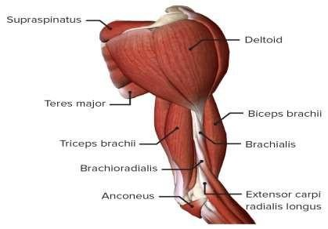
Integration of Disciplines

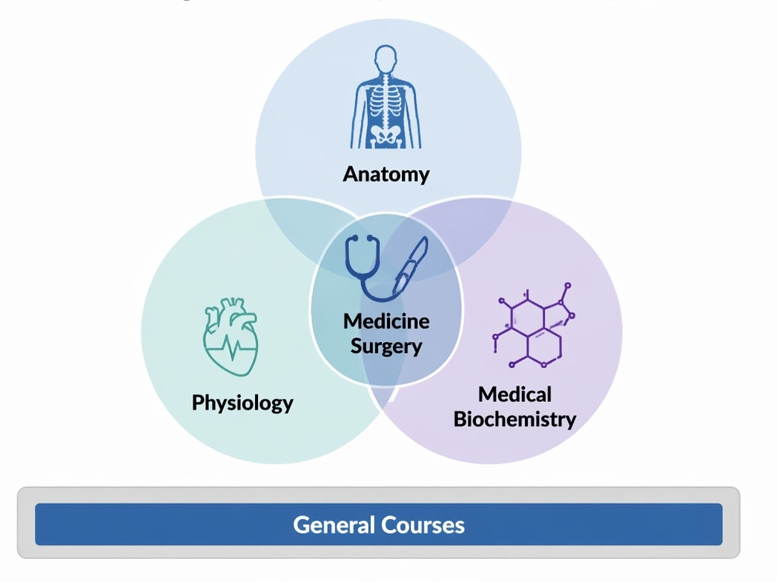

MODULE PLANNING COMMITTEE

Block Coordinator | Dr. Rabia Latif (Anatomy Department)
Module Coordinator+  Members | Anatomy: Dr Tayyaba Mahmud, Dr Shamir A Khan, Dr. Raffia Irfan  Physiology: Dr. Amna Nadeem, Dr. Amna Quddus, Dr. Faiza Habib, Dr. Ujala Ali, Dr. Jaweria Muhamad  Biochemistry: Dr. Hira Saeed, Dr. Faiza Ahmed, Dr/ Maham Zulfiqar, Dr. Adeeba Fatima, Dr. Abida Asghar

At the end of this module, students will be able to:
- Integrate the knowledge of the structure of upper limb with the physiological mechanisms underlying movement and muscle contraction, and the biochemical pathways involved in energy production and muscle metabolism and relate it with their clinical aspects
Learning Outcomes | Subject Learning Outcomes | Teaching & Learning  Strategies | Proposed Assessment  Strategies
- FUNCTIONAL ORGANIZATION OF NERVE & MUSCLE
Correlate the physiological anatomy of nerves and muscles with their clinical significance. | ANATOMY  General Histology Histology of Muscular tissue  - Describe the light microscopic characteristics of skeletal, cardiac, and smooth muscles  - Tabulate the microscopic differences between three types of muscles | LGIS, SGD,  Practical | MCQs, SAQs, SEQs, OSPE,  Structured Viva
 | GENERAL ANATOMY  - Describe the organization of nervous system.  - Enumerate components of central and peripheral nervous system & describe their general features  - Describe the origin, course, and distribution of a typical spinal nerve with the help of a diagram.  - Define: Dermatomes, Receptors, and effectors | LGIS/ SGD | MCQs

Physiology
Nerve Physiology
Neuron & Synapse
- Define, and identify the following regions on a diagram of a motor neuron: dendrites, axon, axon hillock, soma, and an axodendritic synapse.
- Classify synapses on anatomical & functional basis.
- Elucidate structural and functional changes taking place in nerve fibers after injury.
RMP- Resting Membrane Potential
- Grasp concept of Nernst potential and its importance in generation of resting membrane potential.
- Comprehend different mechanisms responsible for the genesis of membrane potential (role of channels, carrier proteins).
- Describe the normal distribution of Na+, K+, and Cl- across the cell membrane, and using the Goldman equation, explain how the relative permeability of these ions create a resting membrane potential
- Explain how the abnormal function of ion channels (channelopathies) can alter the resting membrane potential
Action Potential
- Define action potential. Draw different phases of action potential and explain ionic & electrical changes occurring during each phase of action potential
- Differentiate between absolute and relative refractory periods
- Discuss the role of positive feedback mechanisms in initiation of an action potential
- Distinguish the effects of hyperkalemia, hypercalcemia, and hypoxia on the resting membrane potential & action potential
- Discuss the process of generation of nerve impulse and its transmission in different
types of nerve fibers (myelinated and non-

myelinated nerve fibers) with their characteristics.
- Understand the concept of all or nothing principle in propagation of an action potential
- Explain the concept of saltatory conduction
- Discuss the properties of contiguous conduction
- Differentiate between myelinated and non- myelinated nerve fibers based on their structure and characteristics
Neuromuscular Junction
- Illustrate neuromuscular junction, sequence of events taking place during
Neuromuscular transmission and factors affecting this process
 | Clinical Relevance  - Appreciate the effect of acidosis and alkalosis on synaptic transmission.  - Explain the effect of hypocalcemia on permeability of sodium Channels.  - Explain the pathophysiology of Myasthenia Gravis. | Integrated sessions/CBL/LG IS | MCQs, SAQs, SEQs, OSPE,  Structured Viva
MOVEMENT AND ENERGY
- Correlate carbohydrate metabolism with energy production required for upper limb movements and physiological mechanisms of muscle contraction in health and disease  - Appraise the significance of various carbohydrates, with a detailed exploration of their biochemical pathways, and elucidate the processes of digestion, absorption, and metabolic utilization in the human body | GROSS ANATOMY  Bones of shoulder girdle and upper limb  - Determine the side of clavicle, scapula, humerus, radius ulna  - Identify important bony landmarks on these bones  - Locate attachments of major muscles and ligaments attached on these bones  - Discuss the clinical implications in fractures of these bones at different sites | SGD | - MCQs  - SEQ / SAQ  - OSPE  - Viva Voce
 | Pectoral region and breast  - Comprehend the structure of breast tissue  - Justify the importance of fibrous septa in breast in relation to its carcinoma  - Describe the blood supply and lymphatic drainage of breast  - Justify the clinical importance of sentinel lymph node  - Trace the possible routes of metastasis of breast cancer | SGD/CBL | - MCQs/ SEQs/  - SAQs/  - VIVA

- Tabulate the attachments, nerve supply and actions of muscles attaching upper limb to thoracic wall.
- Describe attachments of pectoral fascia
 | Scapular region  - Tabulate the attachments, nerve supply and actions of muscles attaching upper limb to vertebral column  - Tabulate the attachments, nerve supply and actions of muscles attaching scapula to the humerus  - Identify the boundaries and contents of quadrangular and triangular spaces  - Trace the route and anatomical relationships of arteries and nerves present in this region  - Describe the structure of acromioclavicular and sternoclavicular joints  - Justify the stability of clavicular joints in case of direct blow to clavicle and resultant fracture  - Describe type, ligaments, articular surfaces, blood supply and nerve supply of shoulder joint  - Elucidate the movements at shoulder joint with reference to axis and muscles producing them  - Justify the clinical presentation of shoulder joint dislocation on anatomical basis  - Justify the stability of the shoulder joint in spite of wide range of movements it offers by describing the factors responsible  - Define rotators cuff and list its components  - Justify the clinical presentation of rotator cuff injuries, frozen shoulder and calcific supraspinatus tendinitis based on the anatomical knowledge  - Illustrate the anastomosis around shoulder  joint/scapula | SGD | - MCQs/ SEQs/  - SAQs/  - VIVA

 | Axilla  - Appraise the shape and extent of axilla  - Enumerate different structures forming various walls of axilla and identify their inter-relationship  - Enumerate different contents of axilla  - Describe the relations and distribution of vessels of axilla  - Describe the formation and name the branches of brachial plexus  - Illustrate the brachial plexus  - Elucidate the drainage area of each group of axillary lymph nodes  - Analyze the anatomical basis of clinical presentation in case of injury to long  thoracic nerve | SGD | MCQs SAQ/ SEQ/ OSPE  Viva Voce
 | Arm & Forearm  - Tabulate the attachments, nerve supply and actions of muscles of arm and forearm  - Trace the route and relations of the neurovascular structures of arm and forearm  - Analyze the anatomical basis of clinical presentation in case of injury to various nerves of arm and forearm  - Describe the type, capsule and ligaments of elbow, superior and inferior radio-ulnar joints  - Explain the movements of these joints with reference to axis and muscles performing these movements  - Describe the blood supply and nerve supply of elbow joint  - Justify the anatomical basis of carrying angle  - Correlate the anatomy of these joints with clinical presentations of their dislocation  - Outline the boundaries and contents of cubital fossa in a sequential order  - Justify the clinical importance of blood vessels present in cubital fossa  - Recognize the boundaries of anatomical snuff box and bony landmarks in its floor  - Describe the attachments of, and structures passing deep to flexor and extensor  retinacula in a sequential order | SGD | MCQs/ SEQs/ SAQs/  VIVA

- Elucidate the anatomical basis of clinical presentation of compartment syndrome of forearm, Volkmann’s ischemic contracture, rupture of various tendons and tennis elbow.
- Highlight the clinical significance of radial artery with reference to pulse and BP monitoring and coronary angiography
Hand
- Identify bones of an articulated hand
- Explain the clinical significance of injury to scaphoid and hamate
- Elucidate the salient features of skin of palm and dorsum of hand and discuss its cutaneous innervation
- Describe palmar aponeurosis
- Enumerate the small muscles of hand with their actions and nerve supply
- Describe the fibrous and synovial flexor sheaths of the hand
- Explain the carpal tunnel with reference to its formation and contents
- Analyze the anatomical basis of Dupuytren’s contracture, carpal tunnel syndrome, trigger finger and tenosynovitis of synovial sheaths of flexor tendons
- Describe boundaries & contents of spaces of palm
- Analyze the anatomical basis of palmar, Parona and pulp spaces in case of wound, resultant infections, and route of surgical drainage.
- Revisit the insertion of long flexor and extensor tendons
- Describe the blood supply of hand
- Trace the pathway and distribution of radial, median, and ulnar nerves in hand and correlate with clinical presentation of their
injuries

 | Wrist Joint  - Describe the type, capsule, and ligaments of wrist joint  - Explain the movements of wrist joint with reference to axis and muscles responsible  - Describe the blood supply and nerve supply of wrist joint  - Correlate the anatomical knowledge with clinical presentation of wrist joint dislocation  - Enumerate the structures endangered in case of fall on outstretched hand | SDG | MCQs SAQ/SEQ  Viva Voce
 | Cutaneous innervation of upper limb  - Correlate the dermatomes with the cutaneous innervation of specific nerves in upper limb.  Arm & forearm  - Illustrate cutaneous innervation and dermatomes of upper limb.  - Identify the area of sensory loss in case of injury to different nerves. | SGD | MCQs  SAQs/SEQs Viva Voce
 | Injuries to brachial plexus and its branches  - Revisit the formation and branches of brachial plexus  - Identify the points of injury and justify peculiar positions of upper limb in cases of Klumpke paralysis & Erb-Duchenne palsy with anatomical reasoning  - Identify the anatomical sites where different branches of brachial plexus are vulnerable to injury / compression  - Correlate the lesion of following nerves with respective areas of sensory and motor loss and peculiar positions of different parts of upper limb:  - Axillary  - Long thoracic  - Musculocutaneous  - Ulnar  - Median  - Radial | SGD | MCQs  SAQs/SEQs Viva Voce

 | Venous and lymphatic drainage of upper limb  - Recap the veins in various parts to describe the venous drainage of upper limb as a whole  - Identify the veins commonly used for cannulation  - Discuss the lymphatic drainage of upper limb in detailin correlation with infection  and malignant spread | SGD | MCQs  SAQs/SEQs
 |  | SGD | Viva Voce
 | Surface Marking  - Take consent from the subject  - Expose the relevant part properly  - Mark the following structures on surface of a subject or mannequin correctly:  - Axillary nerve  - Brachial nerve  - Ulnar artery  - Radial artery  - Superficial palmar arch  - Deep palmar arch  - Cephalic vein  - Basilic vein  - Median cubital vein  - Axillary nerve  - Musculocutaneous nerve  - Median nerve  - Radial nerve  - Ulnar nerve  - Cover the exposed part and thank the subject | SGD | MCQs  SAQs/SEQs OSPE  Viva Voce
 | Skills  Identify various muscular, neurovascular, and ligamentous structures of upper limb on models and prosected specimens | SGD | MCQs  SAQs/SEQs OSPE  Viva Voce
 | PHYSIOLOGY  Muscle Physiology  Skeletal muscle morphology  - Illustrate the physiologic anatomy of skeletal muscle  - Explain the structure of myosin molecule& its subunits and describe the function of the  subunits | SGD, CBL | MCQs, SEQs/ SAQs, OSPE,  Structured Viva

- Identify the structure of the thick and thin myofilaments and label the constituent proteins
- Tabulate macroscopic, microscopic, functional differences of various types of muscles
Skeletal muscle contraction and relaxation
- Appreciate the ionic and chemical basis of muscle contraction and relaxation.
- Explain how the cross-bridge cycle results in shortening of the muscle.
- List the steps in excitation-contraction coupling in skeletal muscle, and describethe roles of the sarcolemma, transverse tubules, sarcoplasmic reticulum, thin filaments, and Ca++
- Describe the roles of ATP in skeletal muscle contraction and relaxation.
- Explain the energy expenditure during muscle contraction
- Appreciate the characteristics and differences between isometric and isotonic contraction with the help of examples.
- Compare and contrast slow and fast muscle fibers
- Explain the relationship of preload, afterload and total load in the time course of an isotonic contraction.
Properties of muscle Contraction-I
Explain the motor unit and its physiological importance. Explain the concept of:
- Summation
- Treppe
- Skeletal muscle tone
- Muscle fatigue
- Tetanization
- Contracture remainder
- Muscle dystrophy
Muscle remodeling + Rigor mortis
- Enlist types of muscle remodeling
- Summarize the effects of hypertrophy, hyperplasia & atrophy on the skeletal
muscle structure and function
- Explain the physiological basis of rigormortis

Smooth muscle morphology & characteristics
- Comprehend the types of smooth muscles.
- Differentiate between types of action potentials produced in different smooth muscles and appreciate the role of autonomic innervation, mechanical and humoral factors in their generation
- Appreciate characteristics of smooth muscles (slow cycling of myosin cross- bridge, low energy requirement to sustain contraction, latch mechanism & stress relaxation).
Smooth muscle contraction and relaxation
- Illustrate the sequence of events leading to smooth muscle contraction and relaxation.
- Give an account on the physiological anatomy of smooth muscle NMJ
 | MEDICAL BIOCHEMISTRY  Carbohydrate Chemistry:  - Classify carbohydrates and explain their biochemical functions  - Describe the structure and functions of monosaccharides and list their various derivatives  - Explain the structure and functions of disaccharides and oligosaccharides  - Discuss the structure, functions, and biochemical roles of polysaccharides  - Provide an overview of the digestion and absorption of carbohydrates  Carbohydrate Metabolism:  - Describe the fundamental processes of carbohydrate metabolism and explain their importance in energy production and regulation in the body  - Outline the phase reactions of glycolysis and explain the regulation of key enzymes involved in this pathway  - Compare and contrast aerobic and anaerobic glycolysis, highlighting their bioenergetics and biochemical significance  Describe the HMP shunt (pentose phosphate pathway), its role in producing NADPH and ribose sugars, and explain its importance in protecting cells from oxidative damage | LGIS, SGD | MCQs, SEQs/ SAQs, OSPE,  Structured viva

- Explain the fate of pyruvate and lactic acid in the context of metabolic pathways, including their role in energy production and the Cori cycle
- Outline the reactions of the citric acid cycle and describe its role in cellular respiration and ATP production
- Discuss the energetics, regulation, and significance of the citric acid cycle, focusing on its anaplerotic and amphibolic nature
- Explain the process of gluconeogenesis, including key bypass reactions and the regulation of this pathway in response to hormonal signals
- Describe the metabolism of fructose, galactose, and lactose, emphasizing their conversion into intermediates of glycolysis and gluconeogenesis
- Explain glycogen metabolism, including the processes of glycogenesis and glycogenolysis, and describe the regulation of these pathways
- Write the reactions involved in glycogenesis and glycogenolysis and explain the biochemical importance of UDP-glucose in these processes
- Compare and contrast glycogenesis and glycogenolysis, focusing on their regulation and their roles in maintaining blood glucose levels
- Describe the structure and metabolism of glycosaminoglycans, proteoglycans, and glycoproteins, emphasizing their biological functions and importance in cellular
communication and structure
 | Clinical Relevance  - Define fractures, dislocation and sprain  - Identify various causes of fractures, dislocations and sprains  - List different types of fractures, dislocations in upper limb  - Identify effects of fractures, dislocations and sprains  - List complications of fractures, dislocations in general  - Corelate different fractures of upper limb with nerve & vascular injuries | Integrated sessions/CBL/LGI S | MCQs, SAQs, SEQs, OSPE,  Structured Viva

- Identify common sites of dislocations/sprains in upper limb
- State first aid principles of fracture/dislocations management
- List common nerve injuries and their causes
- Justify the clinical presentations of nerve injuries by giving anatomical reasoning
- Describe including thenar space and pulp
- Enumerate the commonly used imaging techniques used in clinical practice to study normal structure, and diagnose fractures, dislocations & sprains in upper limb
- Explain the basic principles of different densities on X-rays
- Identify appearance of bone, cartilage, air, fluid and fat on x-rays
- Identify different bones of upper limb on Ap and Lateral view of X-rays
- Identify fractures and dislocations in upper limb injuries and corelate with likely important nerve and vessels damage
- Explain pathophysiological basis of Duchenne muscular dystrophy (DMD)
- Explain the mechanism of recovery of muscle contraction in poliomyelitis
- Discuss the clinical significance of glycolysis, including conditions such as pyruvate kinase deficiency, arsenic poisoning, and lactic acidosis
- Discuss biochemical basis of Hemolytic anemia (G6PD deficiency)
- Explain the clinical relevance of the citric acid cycle (TCA) and its involvement in metabolic disorders
- Describe the clinical significance of gluconeogenesis, focusing on disorders related to this pathway
- Correlate the metabolism of fructose, galactose and lactose with relevant metabolic disorders and enzyme deficiencies
Discuss disorders of glycogen metabolism, specifically glycogen storage diseases and their clinical manifestations

Suggested Linkers
FUNCTIONAL ORGANIZATION OF NERVE & MUSCLE | See Clinical Relevance
MOVEMENT AND ENERGY | See Clinical Relevance

Practicals
Anatomy | - Muscle:  - Skeletal Muscle  - Cardiac Muscle  - Smooth Muscle
Biochemistry | - Carbohydrates Qualitative Analysis-I:  - Molisch test  - Carbohydrates Qualitative Analysis-II:  - Benedict test  - Carbohydrates Qualitative Analysis-III:  - Iodine test  - Seliwanoff test

Contents of Block II Module V (Cardiovascular System)
MBBS YEAR I
BLOCK II
MODULE V
CARDIOVASCULAR SYSTEM
DURATION: 09 WEEKS

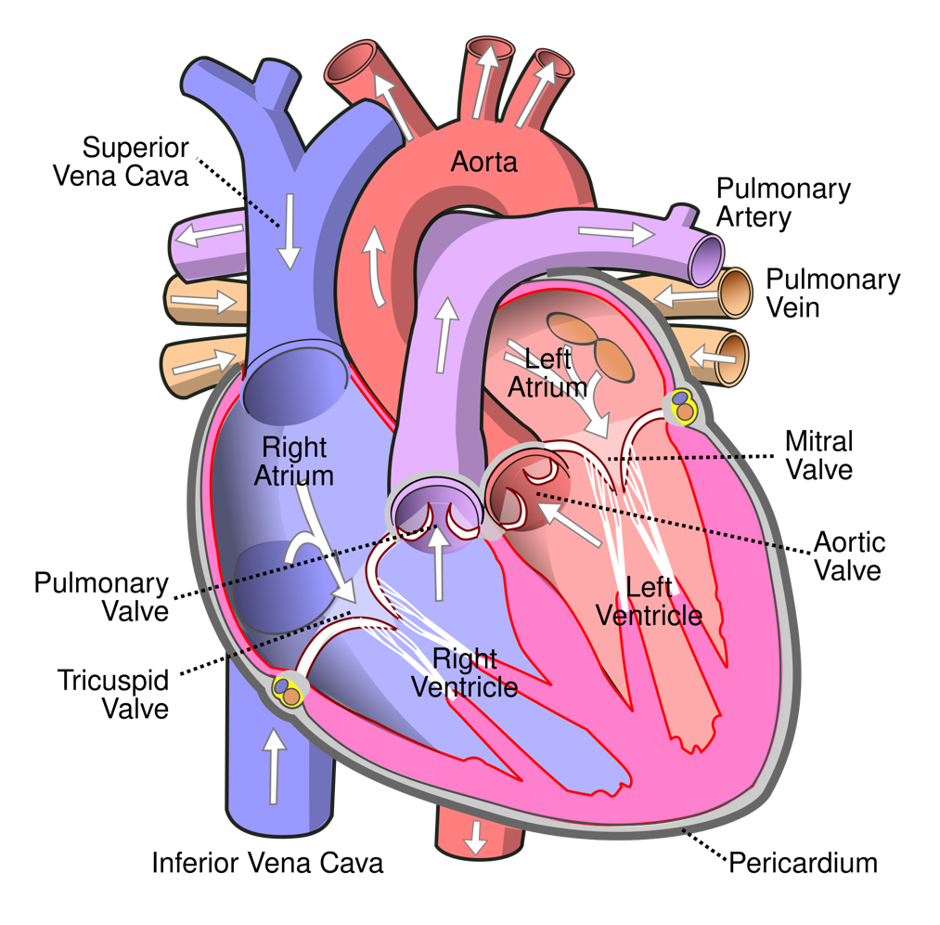
Integration of Disciplines in Module

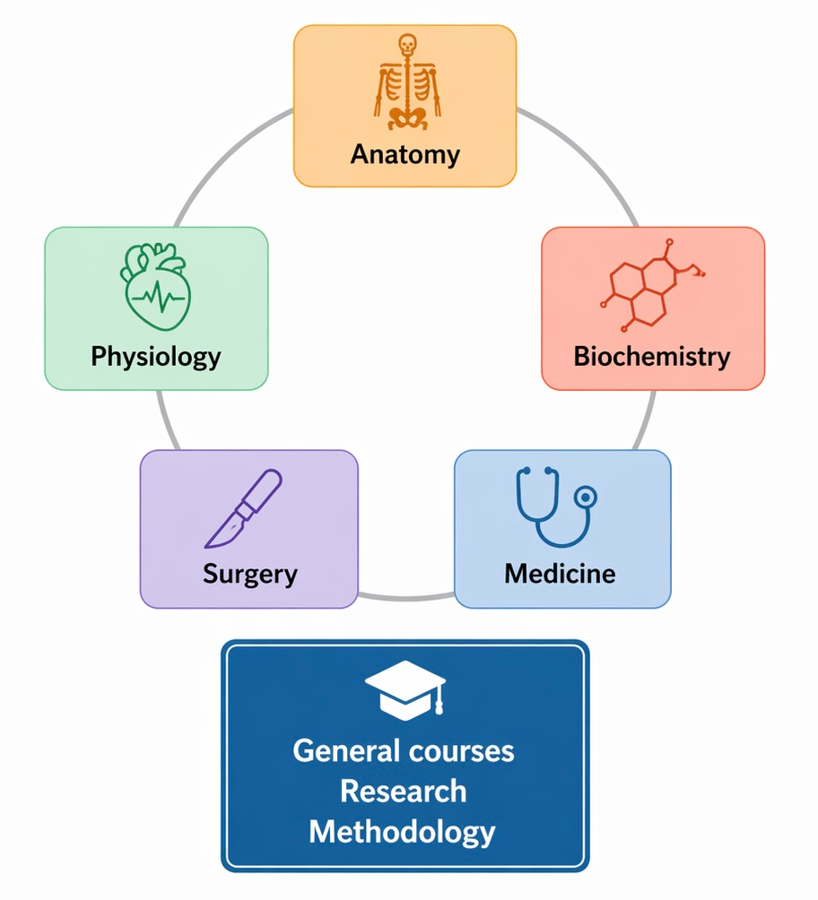

MODULE PLANNING COMMITTEE

Block Coordinator | Dr. Amina Nadeem (Physiology Department)
Module Coordinator /  Members | Anatomy: Dr Tayyaba Mahmud, Dr Shamir A Khan, Dr. Rabia Latif, Dr. Raffia Irfan  Physiology: Dr. Amna Nadeem, Dr. Amna Quddus, Dr. Faiza Habib, Dr. Ujala Ali, Dr. Jaweria Muhammad  Biochemistry: Dr. Faiza Ahmed, Dr. Maham Zulfiqar, Dr. Adeeba Fatima, Dr. Abida Asghar

Preamble
This block focuses on cardiovascular system with basic understanding of structure of thorax. At the very outset medical student should understand that cardiovascular system has fundamental importance in all the fields of Medicine. Coronary artery diseases alone are one of the leading causes of morbidity and mortality worldwide. The course of this block is designed for first year MBBS students in an integrated manner.
Apart from attending daily scheduled sessions, students should engage in self-directed learning to achieve the desired objectives
Module Learning Outcomes:
By the end of this module, students should be able to:
- Integrate the anatomical knowledge of the thorax and heart, physiological mechanisms of cardiac function, and lipids Medical Biochemistry, to relate with clinical conditions of cardiovascular system.
- Correlate the developmental events of fetal period with relevant congenital anomalies.

Integrated Learning  outcomes | Subject Learning outcomes | Teaching &  learning strategies | Assessment  Strategies
At the end of this module, students will be able to:
1. Thoracic wall & Mediastinum
Correlate the gross anatomy of thoracic wall with its  movements and relevant clinical conditions. | Anatomy  - Correlate the cartilaginous, bony and muscular framework of the thoracic cage with its functional and clinical aspects.  - Explain the gross features of thoracic wall including its  blood supply, innervation & lymphatic drainage.  - Describe the joints of thorax with reference to their types and movements  - Differentiate between gross features of typical and  atypical thoracic vertebrae and ribs.  - Demonstrate gross features of sternum  - Recognize gross features of  thoracic wall, including its | SGD/ LGIS/  Practical/ SDL/ CBL | MCQs, SAQs, SEQs, OSPE,  Structured Viva
Integrated Learning  outcomes | Subject Learning outcomes | Teaching &  learning strategies | Assessment  Strategies
layers and contents of a
typical intercostal space on prosected specimens and models.
- Identify the major structures of thoracic wall in standard medical imaging.
- Mark the sternal angle on the surface of giving subject, mentioning the importance of sternal angle with reference to great vessels and rib counting.
- Palpate the surface
projections to mark major thoracic structures in a basic surface examination,
exhibiting ethics,
professionalism and effective communication skills
Clinical relevance
- Interpret the anatomical basis of the following clinical
conditions:
  - Fractures of sternum, ribs and vertebrae, cervical rib
  - Flail chest
  - Thoracotomy
  - Sternal biopsy
  - Thoracic outlet syndrome
  - Dislocation of ribs
- Justify the selection of a site for invasive chest procedures (Intercostal nerve block, chest intubation on right and left side) giving anatomical reasons.

Integrated Learning  outcomes | Subject Learning outcomes | Teaching &  learning strategies | Assessment  Strategies
Relate the topographic  anatomy of major longitudinal structures of thoracic cavity with associated common  clinical conditions. | Anatomy  - Explain the divisions & contents of mediastinum  - Explain the topographic anatomy of major longitudinal structures  (trachea, esophagus, vagus nerves, phrenic nerves, aorta, sympathetic trunk, azygous system and thoracic duct)  running through the thoracic cavity.  - Trace the primary drainage routes of lymph from the organs and wall of the thoracic cavity to the points  of venous connection. | SGD/ LGIS/  Practical/ SDL/ CBL  Integrated session | MCQs, SAQs, SEQs, OSPE,  Structured Viva
 | Clinical relevance:  - Interpret the anatomical basis of following clinical  conditions:  - Deflection of mediastinum  - Mediastinitis  - Mediastinal tumors/ cysts  - Compression of trachea  - Tracheitis/ bronchitis  - Foreign body aspiration  - Bronchoscopy  - Aneurysm & coarctation of aorta  - Patent ductus arteriosus  - Azygos veins & caval obstruction  - Damage/irritation to phrenic nerve | SGD/ LGIS/  Practical/ SDL/ CBL  Integrated session | MCQs, SAQs, SEQs, OSPE,  Structured Viva

Integrated Learning  Outcomes | Subject Learning outcomes | Teaching &  learning strategies | Assessment  Strategies
Analyze the biochemical structure and functions of lipids, while correlating their digestion and absorption processes with relevant clinical disorders. | Medical Biochemistry:  - Define lipids and enumerate their biomedical functions  - Describe lipid classification with examples & biochemical significance including nutritional significance of lipids  - Explain the structure, chemistry, classification and biochemical functions of Fatty acids along with their nutritional role  - Describe the chemistry, functions & biochemical significance of Glycolipids, Phospholipids, Waxes and Steroids e.g. Cholesterol functions and clinical significance.  - Explain rancidity of fats, lipid  peroxidation and its biochemical significance  - Analyze the results of Rancidity of Fats  - Discuss the digestion & absorption of Lipids  Clinical relevance:  - Correlate the digestion and absorption of lipids with  - clinical disorders | SGD/ LGIS/  Practical/ SDL/ CBL  Integrated session | MCQs, SAQs, SEQs, OSPE,  Structured Viva
Integrated Learning  outcomes | Subject Learning outcomes | Teaching &  learning strategies |  | Assessment  Strategies
2. Heart
Interpret the clinical  conditions related to heart, based on anatomical,  physiological and biochemical features | Anatomy  - Relate the topographic anatomy of pericardium and pericardial sinuses with their functional and clinical aspects.  - Explain the gross features of borders, surfaces, apex and base of heart.  - Explain the internal features of various chambers of heart.  - Describe the arterial supply, venous drainage and nerve supply of heart.  - Interpret the clinical  conditions associated with heart on anatomical basis.  - Explain the histomorphological features of heart.  - Explain the development of heart with special  reference to its looping & septa formation in  different parts of heart tube.  - Outline the borders of the heart and the auscultatory areas on the surface of the given subject while  exhibiting effective  communication skills, professionalism and  ethics.  - Identify gross features of heart on museum models and prosected specimens  - Identify blood vessels of heart on museum models and prosected specimens  - Recognize the developmental events of  heart on the given models.  Identify major features of heart in standard medical imaging, | SGD/ LGIS /  Practical/ SDL/ CBL |  | MCQs, SAQs, SEQs, OSPE,  Structured Viva

Integrated Learning  outcomes | Subject Learning outcomes | Teaching &  learning strategies | Assessment  Strategies
 | Physiology
 | - Differentiate the physiological
 | arrangement of right and left
 | hearts along with the parallel
 | arrangement of systemic
 | circulation.
 | - Trace the path of blood flow
 | through the whole circulatory
 | system with comparisons of
 | pressures in various
 | components of heart and
circulatory tree.
- Explain the basic functional
anatomy of the atrioventricular and semilunar valves, and how they operate.
- Compare cardiac and skeletal muscle with respect to: cell
size, electrical connections
between cells, and arrangement of myofilaments, ion
permeability, and electrical resistance.
- Describe role of gap junctions in creating a functional
syncytium.
- Explain the ionic mechanism of pacemaker automaticity and rhythmicity, and identify
cardiac cells that have
pacemaker potential and their spontaneous rate.
- Identify neural and humoral
factors that influence their rate.
- Discuss the significance of “overdrive suppression” and “ectopic pacemaker”.
- Trace the normal sequence of cardiac activation (depolarization) beginning in the SA node, and the role
played by specialized cells of
the cardiac conductive system.
- Explain the functional
significance of the slow
conduction through the AV
node (delay). Describe factors that influence conduction
velocity through the AV node.
- Draw a diagram and trace the path of spread of cardiac impulse through conductive system, atrial and ventricular myocardium and associate it with the function of heart.
- Sketch a typical action potential in a ventricular muscle labeling both the voltage and time axes
accurately.
- Describe how ionic currents through various ion channels
contribute to the four phases of the cardiac action potential.
- Explain what accounts for the long duration of the cardiac
action potential and the
resultant long refractory period and the advantage of the long plateau of the cardiac action
potential and the long refractory period
- Contrast the duration of the action potential and the refractory period in a cardiac muscle and a skeletal muscle.

Integrated Learning  outcomes | Subject Learning outcomes | Teaching &  learning strategies | Assessment  Strategies
- Sketch the temporal
relationship between AP in a cardiac muscle and the resulting contraction of that cell.
- Explain why cardiac muscle cannot remain in a state of
sustained (tetanic) contraction.
- Contrast the sympathetic and parasympathetic nervous system influence on heart rate and cardiac excitation in
general. Identify which arm of the autonomic nervous system is dominant at rest and during exercise.
- Discuss ionic mechanisms of these effects on both working myocardium and pacemaker cells.
- Explain how changes in sympathetic activity alter ventricular work, cardiac metabolism, oxygen consumption and cardiac output.
- Recognize the location of
vasomotor center.

Integrated Learning  outcomes | Subject Learning outcomes | Teaching &  learning strategies | Assessment  Strategies
- Enlist the different parts of
vasomotor center and their functions
- Draw, in correct temporal relationship, the pressure,
volume, heart sound, and ECG changes in the cardiac cycle. Identify the intervals of iso-
volumic- contraction, rapid ejection, slow ejection, iso- volumic relaxation, rapid
ventricle filling, slow
ventricular filling and atrial contraction.
- Compare the various phases of ventricular systole and
ventricular diastole. Contrast the relationship between pressure and flow into and out of the left and right ventricles during each phase of the
cardiac cycle.
- Analyze various cardiac events in relation to each other
- Define ejection fraction and
calculate it from end diastolic volume, end systolic volume, and/or stroke volume.
- Predict the change in ejection fraction that would result from a change in a) preload, b) afterload, and c) contractility.

Integrated Learning  outcomes | Subject Learning outcomes | Teaching &  learning strategies | Assessment  Strategies
- Draw a ventricular pressure
volume loop and label the phases and events of the
cardiac cycle (ECG, valve movement).
- Describe the role of Starling’s Law of the Heart in keeping the output of the left and right ventricles equal.
- Describe the difference in the way changes in preload and
changes in contractility influence ventricular force development.
- Define preload and contractility.
- Explain why ventricular end- diastolic pressure, atrial pressure and venous pressure all provide estimates of
ventricular preload.
- Explain why ventricular end- diastolic pressure provides the most reliable estimate.
- Explain how arterial pressure influences afterload.
- Describe the impact of changes in preload, afterload, and
contractility in determining cardiac performance.
- Define the term dipole.
Describe characteristics that

Integrated Learning  outcomes | Subject Learning outcomes | Teaching &  learning strategies | Assessment  Strategies
define a vector. Describe how
dipoles generated by the heart produce the waveforms of the ECG.
- Describe the electrode
conventions used by clinicians to standardize ECG
measurements. Know the electrode placements and
polarities for the 12 leads of a 12 lead electro-cardiogram and the standard values for pen
amplitude calibration and paper speed.
- Name the parts of a typical
bipolar (Lead II) ECG tracing and explain the relationship
between each of the waves, intervals, and segments in
relation to the electrical state of the heart.
- Explain why the ECG tracing looks different in each of the 12 leads. Correlate between vector and lead, type and
locations of leads and
principles for vector analysis.
- Recognize the significance of waves, segments and intervals of ECG recording.
- Describe the timing and causes
of the four heart sounds.
Integrated Learning  outcomes | Subject Learning outcomes | Teaching &  learning strategies | Assessment  Strategies
- Examine the Heart Sound on
Pulmonary, Aortic, Mitral and Tricuspid areas
- Record & Interpret normal ECG by placing all the chest and limb leads on an SP
- Perform Cardiopulmonary resuscitation on a dummy according to the American
Heart Association Guidelines
Medical Biochemistry:
- Describe the biosynthesis of fatty acids, their regulation and related disorders
- Explain the mobilization and Oxidation of fatty acids along with types of oxidation (beta, alpha, omega & branched chain fatty acids), bioenergetics, regulation and related disorders
- Elaborate the oxidation of fatty acids with odd number of carbon atoms and oxidation of unsaturated fatty acids
- Explain Triglyceride metabolism (Lipogenesis & Lipolysis)
- Explain the metabolism of ketone bodies and correlate their utilization and clinical significance in body
- Estimate & interpret reports of patients with cardiovascular
disease:
  - Serum Cholesterol
  - Serum Triglycerides
  - LDH
  - CK
  - Trop T

Integrated Learning  outcomes | Subject Learning outcomes | Teaching &  learning strategies | Assessment  Strategies
Clinical relevance:
- Explain the surgical
significance of transverse pericardial sinus.
- Interpret the anatomical basis of pericarditis, cardiac tamponade, pericardial rub, pericardial effusion.
- Interpret the anatomical basis of coronary artery disease/ coronary heart disease (angina pectoris and myocardial infarction).
- Interpret the anatomical basis of cardiac referred pain.
- Apply your knowledge of anatomy to appraise the following procedures:
  - Cardiac catheterization
  - Echocardiography
  - Coronary angiography
  - Coronary bypass graft
  - Coronary angioplasty
  - Electrocardiography
  - Paracentesis
  - Artificial cardiac pacemaker
  - Central venous line.

Integrated Learning  outcomes | Subject Learning outcomes | Teaching &  learning strategies | Assessment  Strategies
- Explain the embryological basis of following
congenital anomalies of heart:
- Dextrocardia
- Atrial septal defects
- Premature closure of oval foramen
- Ventricular septal defects
- Endocardial cushion defects
- Tetralogy of Fallot
- Persistent truncus arteriosus
- Transposition of great vessels
- DiGeorge sequence
- Valvular stenosis
- Ectopia cordis
- Describe the expected auscultation sounds that define mitral stenosis, mitral insufficiency, aortic stenosis,
Integrated Learning  outcomes | Subject Learning outcomes | Teaching &  learning strategies | Assessment  Strategies
and aortic insufficiency and
their physiological basis.
- Comprehend congenital heart diseases like Patent Ductus arteriosus and Tetralogy of Fallot.
- Outline neural and humoral factors that influence their rate and significance of “overdrive suppression” and “ectopic pacemaker”.
- Discuss current of injury and describe how it alters the ST segment of the ECG.
- Analyze the alteration in
conduction responsible for most common arrhythmias: i.e., tachycardia, bradycardia,
A V block, bundle branch
block, flutter, and fibrillation
- Discuss the basis of common cardiac arrhythmias and relate with ECG changes.
- Explain the mechanism of myocardial injury during MI and its complications.
- Explain the ECG changes in case of ischemia and differentiate them from
changes in infarction.

Integrated Learning  outcomes | Subject Learning outcomes | Teaching &  learning strategies | Assessment  Strategies
- Differentiate between anterior
wall MI, lateral wall MI, inferior wall MI and Posterior wall MI based on the leads involved.
- Enlist the types of abnormal heart sounds (murmurs)
- Correlate the systolic and diastolic murmurs with valvular heart diseases like stenosis and regurgitation
- Explain the mechanism of myocardial injury during MI
- Explain the ECG changes in case of ischemia and differentiate them from changes in infarction.
- Correlate the ECG changes from the onset of MI to its progression and identification of changes of old MI.
- Differentiate between anterior wall MI, lateral wall MI, inferior wall MI and Posterior wall MI based on the leads involved
- Discuss the basis of common cardiac arrhythmias, process that produce them and their clinical significance.
Integrated Learning  outcomes |  | Subject Learning outcomes |  | Teaching &  learning strategies | Assessment  Strategies
- Employ the concept of sinus
arrhythmia and its clinical significance.
- Compare between first degree, second degree and third degree heart blocks based on pathophysiology and ECG changes.
- Describe the basis of overdrive suppression and Stokes Adams attacks
- Assess changes in ECG and cardiac function during common abnormalities in ionic composition of body fluids.
- Differentiate between fibrillation and flutter based on ECG findings
- Describe the significance of defibrillation in emergency cardiac situations
- Elucidate the significance of cardiac biomarkers in Cardiac Ischemia & Infarction
- Describe the metabolic
disorders of lipid metabolism
3. Vascular system
Interpret the clinical  conditions associated with vascular system based on |  | Anatomy  - Describe general plan  of systemic, pulmonary and portal |  | SGD/ LGIS /  Practical/ SDL/ CBL | MCQs, SAQs, SEQs, OSPE,  Structured Viva
Integrated Learning  outcomes | Subject Learning outcomes |  | Teaching &  learning strategies |  | Assessment  Strategies
anatomical, physiological and  biochemical basis. | circulatory system.  - Classify blood vessels on anatomical and functional basis with the help of examples.  - Differentiate between anatomical end arteries and functional end  arteries by giving examples.  - Explain the anatomical basis and clinical  significance of collateral circulation  - Describe general plan of the lymphatic system of the body.  - Explain the development of vascular system  - Explain fetal circulation by comparing the circulatory changes before and after birth.  - Justify the needs of sites of mixing of oxygenated and  deoxygenated blood in the fetus  - Correlate the microscopic features of arteries, veins and capillaries with their functional & clinical  aspects  - Recognize the  developmental events of vascular system on the given models  - Differentiate among various slides of arteries & veins under light  microscope in H&E stain
Integrated Learning  outcomes | Subject Learning outcomes |  | Teaching &  learning strategies |  | Assessment  Strategies
Physiology:
- Interpret the Law of Laplace. Describe how it applies to ventricular function in the normal and volume overloaded (failing) ventricle.
- Extrapolate the relationship between pressure, flow, and resistance in the vasculature. Apply this relationship to the arteries, arterioles, capillaries, venules, and veins.
- Apply Poiseuille's law to understand the flow in distensible blood vessels.
- Correlate vascular resistance and conductance of blood vessels and association of flow in series vs. in parallel on total resistance.
- Compare turbulent and laminar flow, the concept of pressure gradient, resistance to blood flow and its significance.
- Compare the physiologic anatomy of different types of blood vessels and their importance.
- Discuss the Physiology of vascular compliance, changes in compliance of blood vessels
with age & comparison b/w the
Integrated Learning  outcomes | Subject Learning outcomes |  | Teaching &  learning strategies |  | Assessment  Strategies
compliance of arteries versus
veins.
- Identify the origin of arterial pressure pulse and its propagation to the peripheral arteries.
- Describe the factors damping the arterial pulse and abnormalities of arterial pulse.
- Correlate the right atrial pressure with the factors affecting venous return to heart
- Correlate the venous resistance with Venous valves and muscle pump and gravitational forces with reference to varicose veins
- Describe how the theory of metabolic regulation of blood flow accounts for active hyperemia and reactive hyperemia.
- Identify the role of PO2, PCO2, pH, adenosine, and K+ in the metabolic control of blood flow to specific tissues.
- Diagram the synthetic pathway for nitric oxide (EDRF, endothelial derived relaxing factor), including substrate and the interplay between endothelium and vascular
smooth muscle.
Integrated Learning  outcomes | Subject Learning outcomes |  | Teaching &  learning strategies |  | Assessment  Strategies
- Describe the role of
angiogenesis in providing a long term match of tissue blood flow and metabolic need.
- Identify the cell membrane receptors and second messenger systems mediating the contraction of vascular smooth muscle by norepinephrine, angiotensin II, and vasopressin.
- Identify the cell membrane receptors and second messenger systems mediating the relaxation of vascular smooth muscle by nitric oxide, bradykinin, prostaglandins, and histamine.
- Describe the involvement of endothelial cells in the regulation of vascular diameter and inflammatory responses.
- Describe triple response
- Demonstrate Triple Response
- Explain the determinants of cardiac output i.e. stroke volume output and Heart rate and factors affecting them.
- Appreciate the mechanics of low & high cardiac outputs along with their effects on
heart.
Integrated Learning  outcomes | Subject Learning outcomes |  | Teaching &  learning strategies |  | Assessment  Strategies
- Comprehend the factors
affecting stroke volume, heart rate and total peripheral resistance.
- Understand Fick’s principle for the measurement of cardiac output.
- Understand the concept of “mean systemic filling pressure,” its normal value, and how various factors can alter its value.
- Define venous return. Understand the concept of “resistance to venous return” and know what factors determine its value theoretically, what factors are most important in practice.
- Construct a venous return curve. Predict how changes in right atrial pressure and mean systemic filling pressure effect the venous return
- Understand the principles underlying cardiac output measurements using the Fick, dye dilution, and thermos- dilution methods.
- Contrast the local and neural
control of cerebral blood flow. Discuss the relative importance of O2, CO2, and pH in regulating cerebral blood flow.

Integrated Learning  outcomes | Subject Learning outcomes |  | Teaching &  learning strategies |  | Assessment  Strategies
- Describe the structural components of the blood brain barrier and how this barrier impedes the movement of gases, proteins, and lipids from the blood to neurons.
- Contrast the mechanisms of the two major types of stroke, hemorrhagic and occlusive stroke
- Describe blood pressure measurement with a catheter and transducer and explain the components of blood pressure waveform.
- Contrast the direct and indirect estimation of blood pressure with a sphygmomanometer.
- Given systolic and diastolic blood pressures, calculate the pulse pressure and the mean arterial pressure.
- Describe how arterial systolic, diastolic, mean, and pulse pressure are affected by changes in a) stroke volume, b) heart rate, c) arterial compliance, and d) total peripheral resistance
Integrated Learning  outcomes | Subject Learning outcomes |  | Teaching &  learning strategies |  | Assessment  Strategies
- Comprehend the determinants
of arterial pressure, factors affecting and mechanisms regulating blood pressure on short and long term basis.
- Understand mean arterial pressure and its significance.
- Contrast the sympathetic and parasympathetic nervous system control of heart rate, contractility, total peripheral resistance, and venous capacitance
- Explain the sequence of events in the following that occur after an acute increase or decrease in arterial blood pressure. Include receptor response, afferent nerve, and CNS integration, efferent to the SA node, ventricles, arterioles, venules, and hypothalamus baroreceptor reflex, CNS Ischemic response, Chemoreceptor reflex, Cushing reaction
- Explain the sequence of events mediated by cardiopulmonary volume receptors that occur after an acute increase or decrease in arterial blood pressure. Include receptor response, afferent, CNS integration, efferent to the heart, kidney, hypothalamus, and vasculature.
Integrated Learning  outcomes | Subject Learning outcomes |  | Teaching & learning strategies |  | Assessment  Strategies
- Explain the role of renin- angiotensin-aldosterone
mechanism with the help of a flowsheet diagram in regulation of BP at intermediate term
- Explain the significance of pressure diuresis and pressure natriuresis in long term regulation of BP
- Contrast the relative contribution of short- and long- term mechanisms in blood pressure and blood volume regulation.
- Examine the Radial Pulse and comment on rate, rhythm and character
- Record the Blood Pressure of a Subject using palpatory and Auscultatory Method
- Record the effects of posture
and Exercise on Blood Pressure
Medical Biochemistry
- Explain the steps of Cholesterol synthesis, regulation along with functions and fate in the body
- Discuss the synthesis,
regulation and biochemical functions of Bile Acids and Bile Salts

Integrated Learning  outcomes | Subject Learning outcomes |  | Teaching &  learning strategies |  | Assessment  Strategies
- Elaborate enterohepatic circulation of bile and bile salts
- Discuss the metabolism of Lipoproteins (VLDL, LDL, HDL, and Chylomicrons) with respect to their transport, functions and importance in health and disease
- Discuss Apolipoproteins and their role in lipoprotein metabolism
- Describe the metabolism of Glycoproteins and its related metabolic disorders
- Explain the classification, synthesis, biochemical functions and clinical importance of Eicosanoids
- Interpret lipid profile

Clinical relevance:
- Interpret the histomorphological changes in atherosclerosis, arteriosclerosis and Marfan`s Syndrome.
- Correlate the common congenital anomalies of arterial and venous system with normal developmental process.
Integrated Learning  outcomes | Subject Learning outcomes |  | Teaching &  learning strategies |  | Assessment  Strategies
- Tabulate WHO criteria for
categorizing different types of hypertensions.
- Compare primary and
secondary hypertension. Enlist causes of both.
- Explain Hypercholesterolemia in relation with pathophysiology of Atherosclerosis
4. Lymphoid organs
Relate the histomorphological features of various lymphoid organs to their functions | Anatomy  - Correlate the  histomorphological  features of lymph node, thymus, spleen, palatine  tonsil with their functions.  - Demonstrate the  histomorphological features of lymphoid  organs by focusing the slides at various  magnifications under light microscope and illustrate them with the help of  hematoxylin and eosin.  - Differentiate among various lymphoid organs under light microscope in H&E stained slides :  - Lymph Node  - Thymus  - Spleen  - Palatine Tonsils |  | SGD/ LGIS /  Practical/ SDL/ CBL Integrated session |  | MCQs, SAQs, SEQs, OSPE,  Structured Viva
Integrated Learning  outcomes | Subject Learning outcomes |  | Teaching &  learning strategies |  | Assessment  Strategies
Physiology

- Describe the principles of
capillary dynamics, structure of interstitium, Starling’s forces for fluid exchange across the capillary membrane and factors affecting thereof.
- Recognize the concept of starling’s equilibrium, and how the interstitial space is kept dry
- Explain the mechanism of formation of interstitial fluid, its composition and factors creating starling’s disequilibrium leading to the development of edema.
- Describe how histamine alters the permeability of the post capillary venules, and how the loss of albumin into the interstitial space promotes localized edema.
- Explain how edema develops in response to:
  - venous obstruction,
  - lymphatic obstruction,
  - increased capillary permeability,
  - heart failure,
  - tissue injury or allergic reaction, and
  - malnutrition.
Integrated Learning  outcomes |  |  | Subject Learning outcomes | Teaching &  learning strategies | Assessment  Strategies
- Identify Types of edema, their
pathophysiology and safety factors preventing edema formation
- Determine the JVP on an SP
Clinical relevance:
- Explain the histological basis of tonsillitis.
- Summarize different types of
edema, and safety factors preventing edema formation.
5. Fetal period & Placental Circulation
Correlate the  developmental events of fetal period with relevant congenital anomalies |  |  | Anatomy  - Summarize monthly changes in fetal period  - Calculate the expected date of delivery/ time of birth  - Identify the developmental events of fetal period on the given illustrations & museum models  - Summarize the monthly changes in fetal period on the  given models | SGD/ LGIS /  Practical/ SDL/ CBL  Integrated session | MCQs, SAQs, SEQs, OSPE,  Structured Viva
 |  |  | Clinical relevance  - Enumerate various methods for estimation fetal age  - Differentiate between the  terms of IUGR & SGA, mentioning factors | SGD/ LGIS /  Practical/ SDL/ CBL  Integrated session | MCQs, SAQs, SEQs, OSPE,  Structured Viva
Integrated Learning  outcomes |  |  | Subject Learning outcomes | Teaching &  learning strategies | Assessment  Strategies
affecting fetal growth
- Relate the changes in trophoblast to preeclampsia & its
complication
Correlate the |  |  | Anatomy  - Relate the structure of  placenta to its functional & clinical relevance  - Trace the pathway of placental circulation (maternal & fetal)  - Differentiate between  composition of placental barrier at various stages of development  - Elucidate the mechanism behind the occurrence of various types of multiple pregnancies.  - Explain the production,  circulation and absorption of amniotic fluid.  - Demonstrate types of decidua & chorion, mentioning fate of each on models  - Differentiate among the developmental features of various types of villi in the museum models  - Differentiate between features of maternal and fetal surfaces of full- term placenta on the model.  - Explain the structure of placenta on the given models  - Explain the arrangement  of fetal membranes in various types of multiple  pregnancies on the given models  - Demonstrate the development of umbilical cord on the museum  models | SGD/ LGIS / | MCQs, SAQs,
developmental events of |  |  |  | Practical/ | SEQs, OSPE,
placenta & fetal membranes |  |  |  | SDL/ CBL | Structured Viva
with relevant congenital |  |  |  | Integrated session
anomalies
Integrated Learning  outcomes |  | Subject Learning outcomes |  | Teaching &  learning strategies | Assessment  Strategies
Clinical Relevance:
- Correlate the following anomalies with the
development of placenta:
  - Placenta Previa
  - Placenta accreta, increta, percreta
  - Placenta Succenturiata
  - Placenta Battledore
  - Placenta Velamentosa
- Interpret the
embryological basis of amniotic bands and
umbilical cord defects
- Interpret the
embryological basis of abnormalities related with amniotic fluid volume
- Interpret the
embryological basis of abnormalities associated with multiple pregnancies

6. Heart Failure & Shock
 |  | Anatomy
Integrated Learning  outcomes |  | Subject Learning outcomes |  | Teaching &  learning strategies | Assessment  Strategies
Analyze the anatomical  structure of the diaphragm, the physiological mechanisms underlying cardiac failure and various types of shock, and correlate their clinical presentations with the physiological basis for treatment and management. |  | - Relate the development,  structure & position of  diaphragm with its functional & clinical aspects.  - Describe the role of diaphragm, thoraco-  abdominal muscles and  thoracic cage in changing the diameters of thoracic cavity and mechanics of respiration  - Describe the formation of intraembryonic coelom and its divisions  - Correlate the effects of folding with relocation of different parts of  intraembryonic coelom  - Elucidate the processes involved in partitioning of intraembryonic coelom into definitive body cavities  - Explain the contribution of different developmental sources of Diaphragm  - Correlate the nerve supply of diaphragm with its  developmental sources  - Describe development of ribs, vertebrae with its  congenital anomalies  (scoliosis, kyphosis)
Integrated Learning  outcomes | Subject Learning outcomes |  |  | Teaching &  learning strategies | Assessment  Strategies
 | Physiology  - Differentiate between the factors causing hyper-effective and hypo effective heart.  - Differentiate the mechanisms underlying compensated and uncompensated heart failure.  - Explain stages of development of shock.  - Differentiate compensated and  uncompensated shock |  |  | SGD/ LGIS /  Practical/ SDL/ CBL  Integrated session | MCQs, SAQs,  SEQs, OSPE,  Structured Viva
 | Clinical Relevance
- Correlate the anomalies of ventral body wall and
diaphragm with normal development
- Explain the clinical scenario
related to diaphragmatic hernia and phrenic nerve lesions with anatomical reasoning
- Differentiate between right and left heart failure based on their pathophysiology and clinical manifestation.
- Outline the physiology of treatment of cardiac failure
- Outline the etiology, presentation and management of:
  - Hypovolemic shock
Integrated Learning  outcomes | Subject Learning outcomes |  |  | Teaching &  learning strategies | Assessment  Strategies
- Cardiogenic shock
- Anaphylactic shock
- Neurogenic shock
- Septic shock
ANATOMY PRACTICALS
Recognize gross features of thorax on museum models/ prosected specimens/ radiographs. | Skill:  - Differentiate between gross features of typical and atypical thoracic vertebrae and ribs.  - Demonstrate gross features of sternum  - Recognize gross features of thoracic wall, including its layers and contents of a typical intercostal space on prosected specimens and models.  - Identify the major structures of thoracic wall in standard medical imaging.  - Identify parts of tracheobronchial tree in standard medical imaging.  - Demonstrate division and contents of mediastinum on the models.  - Identify gross features of heart on museum models and prosected specimens  Identify major features of heart in standard medical imaging |  |  | Practical | OSPE
Recognize developmental events of cardiovascular system & fetal period on museum  models/ figures. | - Recognize the developmental events of cardiovascular system on the given models  - Demonstrate types of decidua & chorion, mentioning fate of each on models  Explain the structure of placenta on the given models
Outline major structures of thorax on the surface of given subject exhibiting ethics, professionalism & effective communication  skills. | Attitude:  - Mark the sternal angle on the surface of giving subject, mentioning the importance of sternal angle with reference to great vessels and rib counting.  - Outline the borders of the heart and the auscultatory areas on the surface of the given subject while exhibiting effective communication skills, professionalism and ethics.

ANATOMY PRACTICALS
Outline the course of trachea and thoracic aorta on the surface
of given subject exhibiting ethics, professionalism & effective communication skills.
Recognize the slides of | Skill:  - Differentiate among various slides of arteries & veins under light microscope in H&E stain  - Differentiate among various lymphoid organs under light microscope in H&E stained slides:  - Lymph Node  - Thymus  - Spleen  - Palatine Tonsils  - Demonstrate the histomorphological features of circulatory system & lymphoid organs by focusing the slides at various magnifications under light microscope and illustrate them with the help of hematoxylin and eosin. | Practical | OSPE
circulatory system and
lymphoid organs under
light microscope in
H&E-stain

PHYSIOLOGY PRACTICALS
Record the Blood Pressure of a Subject using palpatory and Auscultatory Method | - Demonstrate the use of stethoscope  - Identify various parts of sphygmomanometer and stethoscope  - Demonstrate the palpatory & auscultatory methods of recording blood pressure  - Record the arterial blood pressure by properly placing the cuff 2.5 cm above the cubital fossa and placing the stethoscope on the brachial artery on the medial side of biceps tendon.  - Recognize the 4 types of Korotokoff sounds, their physiological basis and relevance to systolic and diastolic blood pressure  ATTITUDE  - Practice the art of taking consent from the subject/patient prior to performance of procedure.  - Communicate the procedure effectively to the patient | Practical | OSPE

PHYSIOLOGY PRACTICALS
Perform Cardiopulmonary resuscitation on a dummy according to the American Heart Association Guidelines | SKILLS  - Identify factors/indications for CPR  - Perform CPR according to American Heart Association guidelines  - Practice the art of giving compressions on both adult and infant manikins  - Demonstrate the use of Ambu bag with mask | Practical | OSPE
Demonstrate Triple Response | SKILLS  - Demonstrate the three stages of response of skin (its micro vessels) to blunt mechanical injury  - Proficiently elicit local axon reflex by carefully applying a  stroke on the skin | Practical | OSPE
Record & Interpret normal ECG by placing all the chest and limb leads on an SP | SKILLS  Recording of ECG  - Practice the procedure to record ECG by placing appropriate chest and limb leads on appropriate points and by adjusting the speed and calibration of the ECG machine  - Properly position the patient observing the required precautions during the recording of ECG  - Obtain a 12 lead ECG recording with a long lead II for measurement of heart rate and identification of irregular rhythm  - Identify normal ECG waves, complexes, segments and intervals  - Assess cardiac axis, rhythm, origin of cardiac impulse (pace maker) and calculate heart rate from ECG  - Categorize the conditions affecting the ECG recording  - Identify bradycardia, tachycardia, and MI by examining the ECG  ATTITUDE  - Practice the art of taking consent and communicating with the patient prior to conducting ECG | Practical | OSPE

PHYSIOLOGY PRACTICALS
- Explain the procedure, reassure and communicate the
precautions to be taken by the patient
Examine the Radial Pulse and comment on rate, rhythm and character | Skill  Recording of arterial pulse  - Record the Radial artery pulse by placing three fingers on radial side of semi-pronated arm and counting for one minute.  - Observe the volume, rhythm and character of the pulse  - Compare the radial pulse with the carotid and femoral pulses and note any delay  - Palpate the carotid and dorsalis pedis pulses  ATTITUDE  - Introduce yourself to the subject/patient prior to performance of procedure and take consent  - Explain the procedure of conducting arterial pulse  measurement to the patient | Practical | OSPE
Examine the Heart Sound on Pulmonary, Aortic, Mitral and Tricuspid areas | SKILLS  Auscultation of heart  - Properly expose and position a subject and identify the different cardiac areas for auscultation of mitral, tricuspid, pulmonary and aortic valves  - Demonstrate the auscultation of heart sounds by proper use of stethoscope  - Differentiate between first and second heart sounds  - Appraise the physiological basis of various heart sounds  - Demonstrate the location and palpation of apex beat on precordium  - Recognize the displacement of apex beat and its relevance  to diseases of heart | Practical | OSPE
Determine the JVP on  an SP | Recording JVP  - By adjusting position of subject’s head and neck | Practical | OSPE

PHYSIOLOGY PRACTICALS
Record the effects of posture and Exercise on Blood Pressure | Measurement of arterial blood pressure  - Record the arterial blood pressure by properly placing the cuff 2.5 cm above the cubital fossa and placing the stethoscope on the brachial artery on the medial side of biceps tendon.  - Record the effects of changing posture and performing standard exercise on blood pressure  ATTITUDE  - Practice the art of taking consent from the subject/patient prior to performance of procedure.  - Communicate the procedure effectively to the patient | Practical | OSPE

Medical Biochemistry Practical:
Analyze the results | Rancidity of Fats | Practical | OSPE
of given experiment | Rancidity of Fats
of given experiment | - Estimation & clinical interpretation of patients with
 | cardiovascular disease:
 | - Serum Cholesterol
 | - Serum Triglycerides
 | - LDH
 | - CK
 | - Trop T
 | Interpretation of Lipid Profile

PROPOSED LINKERS
Thoracic wall & Mediastinum | Trauma to thoracic wall
Heart | Chest pain, Arrhythmias, Cyanotic Heart disease
Vascular System | Hypertension
Lymphoid organs | Edema
Fetal period & Placental Circulation | Intra Uterine Growth Retardation, Placenta Previa, Oligohydramnios, Polyhydramnios

Heart Failure & Shock | CCF, Shock

Contents of Block III Module VI (Respiratory System)

MBBS YEAR I
BLOCK III
MODULE VI
RESPIRATORY SYSTEM
DURATION: 04 WEEKS

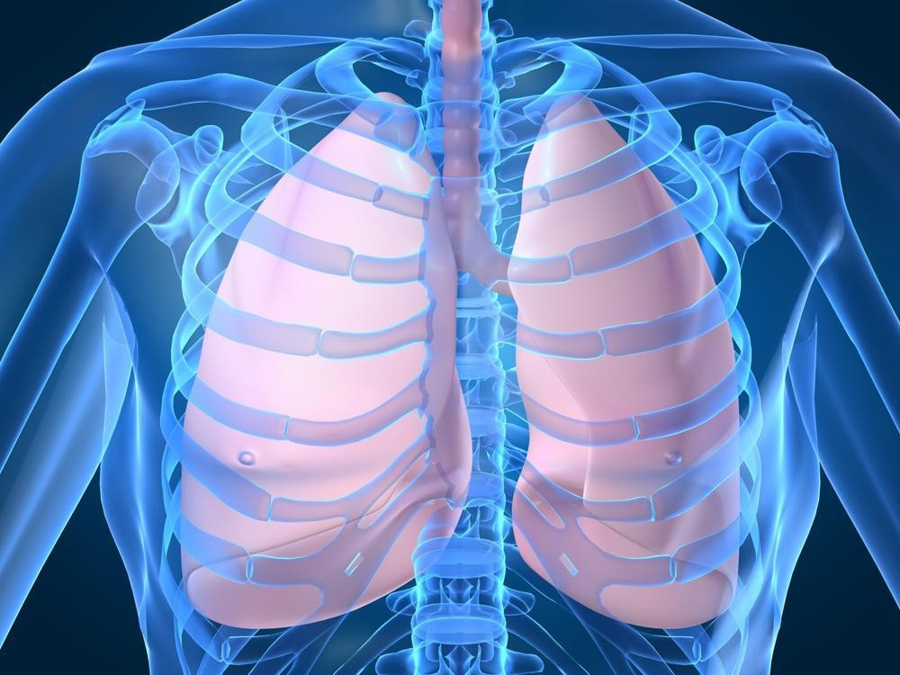

Integration of Disciplines in Module

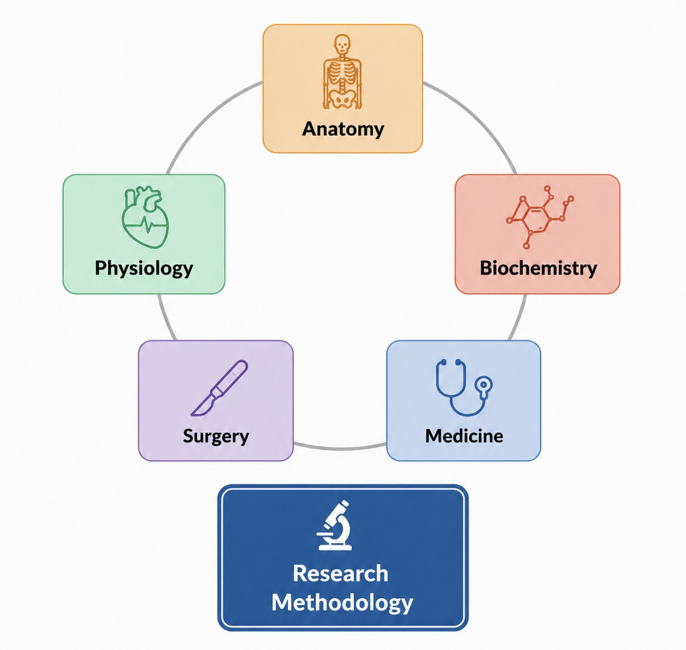

MODULE PLANNING COMMITTEE

Block Coordinator | Dr. Amina Nadeem (Physiology Department)
Module Coordinator /  Members | Anatomy: Dr Tayyaba Mahmud, Dr Shamir A Khan, Dr. Rabia Latif, Dr. Raffia Irfan  Physiology: Dr. Amna Nadeem, Dr. Amna Quddus, Dr. Faiza Habib, Dr. Ujala Ali, Dr. Jaweria Muhammad  Biochemistry: Dr. Faiza Ahmed, Dr. Maham Zulfiqar, Dr. Adeeba Fatima, Dr. Abida Asghar

Preamble
One of the unfortunate gifts of industrialization is varied respiratory illnesses. However, high prevalence of chronic respiratory diseases, mortality and morbidity associated with it is a burden that is not limited to affluent countries. According to a lancet report, nearly 545 million of world population (7.4% of world’s population) suffers from chronic respiratory condition. However, disability remains highest in our part of the world (South Asia), where premature mortality from chronic respiratory diseases is highest! Risk factors for men include air pollution, cigarette and sheesha smoking causing rise in COPD cases. Amongst women, exceptions exist, as household air pollution from solid fuels and ambient particulate matter are the were the leading cause. Genetics also play a part in diseases like asthma, sarcoidosis, interstitial lung diseases. However, certain lifestyle and behavioral modifications can overcome genetic and environmental factors improving the morbidity. Therefore, a firm understanding of the respiratory system is very important for undergraduate students so that they can manage these diseases in clinical settings reducing disease burden in society.
This module focuses on respiratory system along with knowledge of Bioenergetics and Biological Oxidation and Vitamin. Content of ‘Gross Anatomy of thorax, development of body cavities and diaphragm” will be taught in block-II. However, revisit of thorax (lungs pleura and respiratory movements) is included in this block for integration with physiology.
The research methodology will be taught as a part of the longitudinal theme.
Apart from attending daily scheduled sessions, students should engage in self-directed learning to achieve the desired objectives
Module Learning outcomes:
By the end of this module, students should be able to:
- Integrate the anatomical knowledge of respiratory systems with their physiological and biochemical basis to interpret the presentation of common clinical conditions related to respiratory tract.
- Correlate the development of body cavities and diaphragm with the common congenital anomalies

Learning Outcomes | Subject Learning Outcomes | Teaching & Learning Strategies | Proposed  Assessment Strategies
At the end of this module, students will be able to:
Diaphragm & Pleura (Pneumothorax, Pleurisy, Congenital Diaphragmatic Hernia)
Correlate the anatomy of pleura, ribs and sternum with its functions and biochemical basis in normal and disease state | Anatomy:  - Correlate various parts, reflections and recesses of pleura, pleural cavity, ribs and sternum with common clinical conditions  - Identify parts & list the apertures in diaphragm with their levels and structures passing through each on a model. | SGD, LGIS & CBL | MCQs, SAQs, SEQs, OSPE,  Structured Viva
 | Physiology  - Discuss the respiratory and non- respiratory functions of respiratory system. | SGD, LGIS & CBL | MCQs, SAQs, SEQs, OSPE,  Structured Viva

Learning Outcomes | Subject Learning Outcomes | Teaching & Learning Strategies | Proposed  Assessment Strategies
- Summarize the mechanism of cough and sneeze reflex
- Discuss functions of respiratory muscles and their role in quiet and forceful respiration.
- Correlate various pressures acting on lungs and chest wall.
- Interpret the change in alveolar, intra- pleural and trans-pulmonary pressures during each phase of respiration.
Pulmonary Compliance
- Explain lung and chest wall compliance.
- Discuss the composition & role of surfactan in alveolar surface tension.
- Comprehend the concept of work of breathing.
Lung volumes and capacities
- Correlate static & dynamic lung volumes/capacities with the help of normal spirogram

Chemical and neural regulation of respiration

- Explain different group of neurons composing respiratory center.
- Discuss Hering-breuer reflex.
- Discuss the regulation of respiration by
interplay of central & peripheral chemoreceptors

Learning Outcomes | Subject Learning Outcomes | Teaching & Learning Strategies | Proposed  Assessment Strategies
 | Medical Biochemistry  - Give the overview of chemistry of phospholipids.  - Elaborate the metabolism of  phospholipids | MCQs, SAQs, SEQs, OSPE,  Structured Viva | MCQs, SAQs, SEQs, OSPE,  Structured Viva
 | Clinical Relevance:  - Explain the embryological basis of Vertebral defects (Klippel-Feil Syndrome, Spina bifida, Chordoma, variations in number of vertebrae, Hemivertebrae, Rachischisis), Rib defects (Accessory ribs, Fused ribs, Cervical rib) and Defects of sternum  - Justify anatomical basis of referred shoulder tip pain in diaphragmatic irritation.  - Recognize signs, symptoms and radiological findings of pleural effusion, pneumothorax, empyema and hemothorax.  - Discuss pathophysiology of acute respiratory distress syndrome in infants.  - Differentiate between obstructive & restrictive lung diseases based on spirometry  - Correlate the biomedical significance of Phospholipids in Acute Respiratory Distress Syndrome (ARDS)  - Discuss the clinical significance of  Phospholipids (Paroxysmal nocturnal | Integrated sessions/CBL/LGIS | MCQs, SAQs, SEQs, OSPE,  Structured Viva

Learning Outcomes | Subject Learning Outcomes | Teaching & Learning Strategies | Proposed  Assessment Strategies
hemoglobinuria, Niemann pick disease,
role of phospholipases in poisoning)
Lungs (Bronchogenic Carcinoma)
Relate the anatomical structures and physiological functions of lungs, to its clinical significance | Anatomy  - Discuss the gross features, blood supply, nerve supply, and lymphatic drainage of both lungs  - Correlate bronchopulmonary segments with their position and significance.  - Describe the development of trachea and different stages of lung maturation.  - Correlate the cells comprising respiratory and olfactory epithelium with their clinical significance  - Differentiate between the light microscopic structure of conducting and gas exchange portion of respiratory system  - Describe the components forming blood air barrier and the role of type-II alveolar cells in surfactant production.  - Identify the side of lung correctly by recognizing its borders, surfaces, and hilar apertures on the model and cadaveric specimen  - Relate progressive modifications of wall of respiratory tract (from trachea down to alveoli) with its function  - Demonstrate the histomorphological  features of the trachea, bronchus, | LGIS, SGD, CBL,  Practical | MCQs, SAQs, SEQs, OSPE,  Structured Viva

Learning Outcomes | Subject Learning Outcomes | Teaching & Learning Strategies | Proposed  Assessment Strategies
bronchioles and alveoli by focusing the slides at various magnifications under light microscope and illustrate them with
the help of hematoxylin and eosin.
 | Physiology  Pulmonary Circulation  - Differentiate between pressure in systemic and pulmonary circulation.  - Appraise the dynamics of fluid exchange across lung capillary membranes.  - Discuss safety factor in prevention of pulmonary edema  - Describe the pulmonary blood flow in three zones of lung  Principles of gas exchange and gas laws  - Explain concept of partial pressure gradients and their effect on gas exchange on the basis of Fick’s law, Boyle’s law, Dalton’s law and Henry’s law.  - Explain the basis of differences in partial pressures of alveolar and atmospheric air.  - Describe the renewal of alveolar air.  - Discuss the factors affecting gas diffusion through respiratory membrane  Dead Space  - Discuss effect of dead space on alveolar ventilation  - Associate the changes in respiratory  membrane in common respiratory diseases | LGIS, SGD,  Practical | MCQs, SAQs, SEQs, OSPE,  Structured Viva

Learning Outcomes | Subject Learning Outcomes | Teaching & Learning Strategies | Proposed  Assessment Strategies
Ventilation perfusion Ratio

- Explain ventilation perfusion ratio in light of physiological dead space and shunt in all zones of lungs
- Comprehend the concept of respiratory quotient
 | Clinical Relevance:  - Describe the mechanism of development of pulmonary edema and pleural effusion.  - Associate how ventilation perfusion ratio changes in various common respiratory diseases  - Appraise the embryological basis of various types of tracheoesophageal fistulae & justify their relationship with polyhydramnios.  - Analyze embryological basis and prevention of respiratory distress syndrome in a premature infant  - Appraise the embryological basis of immotile cilia syndrome  - Discuss with anatomical reasoning, the clinical presentation of bronchogenic carcinoma and lung trauma.  - Explain surgical aspect of various diseases  of chest wall, lungs, and pleura | Integrated session/LGIS/CBL | MCQs, SAQs, SEQs, OSPE,  Structured Viva

Learning Outcomes | Subject Learning Outcomes | Teaching & Learning Strategies | Proposed  Assessment Strategies
 | - Identify normal features of soft and bony tissues of thorax on chest X-rays
Oxygen & Carbon dioxide transport (Carbon Monoxide Poisoning)
Compare the different modes of gas transport in blood (oxygen and carbon dioxide) and correlate with the biochemical aspect of gaseous exchange | Physiology  - Appraise the mechanism of oxygen transport in the arterial blood.  - Discuss the role of Hb in oxygen transport, keeping in view oxygen-hemoglobin dissociation curve and how this curve shifts in various conditions.  - Discuss the various chemical forms in which CO2 is transported in blood.  - Interpret the normal CO2 dissociation curve in relevance with Haldane, Bohr effect and chloride shift. | LGIS, SGD,  Practical | MCQs, SAQs, SEQs, OSPE,  Structured Viva
 | Medical Biochemistry  - Describe the structure of Hemoglobin and Myoglobin  - Elaborate the globin gene organization  - Discuss various types of Hemoglobin and explain its functions in detail  - Correlate the Oxygen binding capacity of  hemoglobin and myoglobin with reference to the O2- Hb dissociation curve | LGIS, SGD,  Practical | MCQs, SAQs, SEQs, OSPE,  Structured Viva

Learning Outcomes | Subject Learning Outcomes | Teaching & Learning Strategies | Proposed  Assessment Strategies
 | - List various factors affecting and regulating the oxygen binding capacity of hemoglobin
 | Clinical Relevance:  - Explain the clinical disorders related to oxygen-Hb binding capacity (Carbon Monoxide Poisoning, Cyanide poisoning and Methemoglobinemia)  - Explain various Hemoglobinopathies (Hb-S, Hb-C, Hb-SC and thalassemia) | Integrated session/LGIS/CBL | MCQs, SAQs, SEQs, OSPE,  Structured Viva
Abnormal breathing patterns
Analyze the physiological and biochemical mechanisms underlying abnormal breathing patterns, hypoxia, and hypercapnia and appraise the role of hyperbaric oxygen | Physiology  Abnormal breathing patterns  - Identify and discuss different factors causing abnormal breathing patterns (irritants, brain edema, anesthesia)  Hypoxia and hyperbaric oxygen therapy  - Discuss various types of hypoxia, their effects and role of oxygen therapy (hyperbaric oxygen therapy).  - Summarize cyanosis and dyspnea | LGIS, SGD | MCQs, SAQs, SEQs, OSPE,  Structured Viva

Learning Outcomes | Subject Learning Outcomes | Teaching & Learning Strategies | Proposed  Assessment Strategies
therapy in different respiratory diseases | - Discuss hypercapnia & its association with various forms of hypoxia
therapy in different respiratory diseases | Medical Biochemistry  - Correlate the chemistry & biomedical significance of respiratory proteins (Hb, Mb, alpha 1 anti-trypsin, elastin,  cytochrome oxidase, IgA) | LGIS, SGDs | MCQs, SAQs, SEQs, OSPE,  Structured Viva
therapy in different respiratory diseases | Clinical relevance  - Discuss pathogenesis and clinical features of obstructive lung diseases (Chronic Bronchitis, Asthma, Emphysema ; Bronchiectasis)  - Comprehend the concept of Cheyne- Stokes breathing  - Discuss pathophysiology of sleep apnea.  - Elaborate the biochemical basis of emphysema  - Discuss the causes and pathophysiology of pneumonia and TB  - Summarize pathogenesis and clinical  features of different obstructive & restrictive lung diseases | Integrated session/LGIS/CBL | MCQs, SAQs, SEQs, OSPE,  Structured Viva

Learning Outcomes | Subject Learning Outcomes | Teaching & Learning Strategies |  | Proposed  Assessment Strategies
 | - Summarize the role of hyperbaric oxygen therapy in different respiratory diseases
Vitamins (Xerophthalmia, Scurvy, Peripheral Neuropathy)
Relate the knowledge of water-soluble and fat-soluble vitamins for understanding respective deficiency and excess manifestations | Medical Biochemistry  - Classify types of vitamins  - Discuss chemistry, sources, biochemical functions, metabolism and daily allowance of Water-soluble vitamins (Vitamin B Complex and Vitamin C)  - Discuss chemistry, sources, biochemical functions, Metabolism and daily allowance of Fat-soluble vitamins (Vitamin A, D, E and K)  Clinical relevance  - Discuss deficiency manifestations and hypervitaminosis of Water-soluble vitamins  - Discuss deficiency manifestations and hypervitaminosis of Fat-soluble vitamins  - Correlate the biomedical  effects of Vitamin A deficiency with acute respiratory Infection | Integrated session/LGIS/CBL |  | MCQs, SAQs, SEQs, OSPE,  Structured Viva
Anatomy | Physiology | Biochemistry
Learning Outcomes | Subject Learning Outcomes |  | Teaching & Learning Strategies | Proposed  Assessment Strategies
Identify and  illustrate the microscopic structure of following:  - Trachea  - Lungs | - Examine the respiratory system of the given subject (inspection, palpation, percussion and auscultation)  - Study the spirometer and operate the instrument.  - Record the lung volumes and capacities  - Record the forced expiratory Spirogram by using student’s spirometer  - Measure the peak expiratory flow rate (PEFR) and report the reading  - Analyze respiratory acidosis and  respiratory alkalosis with the help of arterial blood gases (ABG) report |  | - Estimation & clinical interpretation of Vitamin C  - Interpretation of HbA1c  - Estimation and clinical interpretation of Plasma Proteins

Linkers of Integrated Session;

PROPOSED LINKERS
Diaphragm & Pleura | Pneumothorax, Pleurisy, Congenital Diaphragmatic Hernia
Lungs | Bronchogenic Carcinoma
Oxygen & Carbon dioxide transport | Carbon Monoxide Poisoning
Abnormal breathing patterns | Hypoxia
Vitamins | Xerophthalmia, Scurvy, Peripheral Neuropathy

Contents of Block III Module VII (Musculoskeletal System II)

MBBS YEAR I
BLOCK III
MODULE VII
MUSCULOSKELETAL SYSTEM – II
DURATION: 05 WEEKS

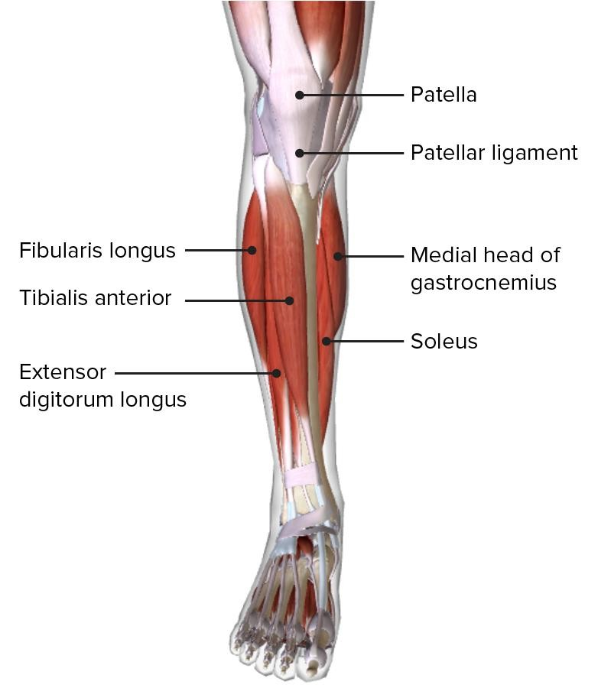

Integration of Disciplines in Module

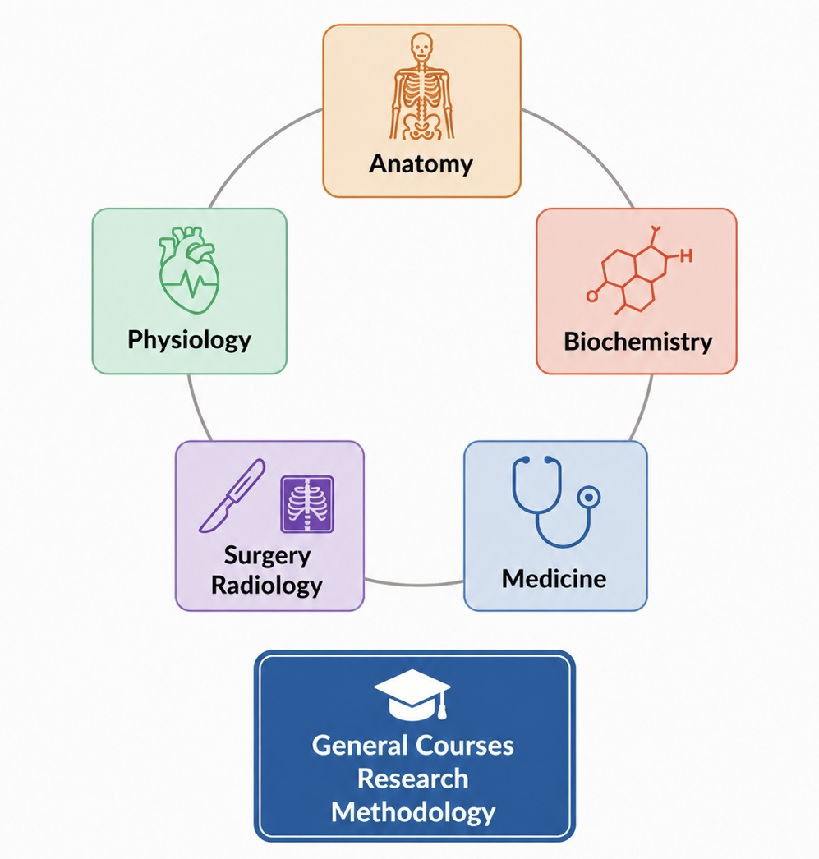

MODULE PLANNING COMMITTEE

Block Coordinator | Dr. Amina Nadeem (Physiology Department)
Module Coordinator /  Members | Anatomy: Dr Tayyaba Mahmud, Dr Shamir A Khan, Dr. Rabia Latif, Dr. Raffia Irfan  Physiology: Dr. Amna Nadeem, Dr. Amna Quddus, Dr. Faiza Habib, Dr. Ujala Ali, Dr. Jaweria Muhammad  Biochemistry: Dr. Faiza Ahmed, Dr. Maham Zulfiqar, Dr. Adeeba Fatima, Dr. Abida Asghar

Preamble
The locomotor system is responsible for locomotion, support and protection to the human body. This system consists of osteology (the study of bones), arthrology (the study of joints), and myology (the study of muscles) of lower limb
Apart from attending daily scheduled sessions, students should engage in self-directed learning to achieve the
desired objectives
Module Learning Outcomes:
By the end of this module, students should be able to:
Apply the knowledge of musculoskeletal system based on anatomical, physiological and biochemical basis to understand relevant clinical conditions

Block- III Module - VII
MUSCULOSKELETAL SYSTEM II
Integrated Learning Outcome | Subject Learning Outcomes | Teaching & Learning  Strategies | Proposed Assessment  Strategies
At the end of this module, students will be able to:
Bone & Muscle Energy Metabolic System (Muscle fatigue & Osteoarthritis)
Correlate the muscle metabolic energy systems with the anatomical, physiological and biochemical basis of musculoskeletal system | Anatomy  - Correlate microscopic structure of bones and cartilage with their function and dysfunction  - Describe the development of limbs and muscles  Physiology  - Correlate the various muscle metabolic systems used as energy substrates with the type of exercise i.e. aerobic and anaerobic  - Explain how each of the above can alter exercise performance in various types of exercises keeping in view the gender and genetic (slow and fast twitch fibers) differences.  - Discuss the cardiovascular and respiratory changes during exercise with emphasis on the principal of VO2max. | SGD/ LGIS/  Practical/SDL/ CBL | MCQs, SAQs, SEQs, OSPE,  Structured Viva

Integrated Learning Outcome | Subject Learning Outcomes | Teaching &  Learning Strategies | Proposed  Assessment Strategies
- Discuss the concept of oxygen debt Clinical Relevance
  - Elucidate the sweat glands adaptation in
warm climate leading to electrolyte imbalance
Biochemistry
- Classify amino acids and explain their biochemical functions
- Discuss amino acid isomers
- Explain the buffering action of amino acids
- Discuss protein structure and levels of protein organization
- Elaborate Protein folding mechanism
- Explain the separation techniques for proteins (gel electrophoresis, centrifugation, chromatography, salting out)
- Discuss in detail the biochemical structure and functions of collagen and elastin
- Elaborate the metabolism of branched chain amino acids
Explain the metabolism of creatine
Clinical Relevance:
- Correlate the histomorphological features of bones and cartilage with the relevant and common clinical conditions.
- Discuss the congenital anomalies related to the development of limbs and muscles
- Explain the congenital malformations associated with various common teratogens related to the muscles and limbs.
- Elaborate the phenomenon of Muscle fatigue
  - Elucidate the diseases associated with the metabolism of branch chain amino acids
  - Give an explanation to the disorders related to protein misfolding
  - Elucidate the diseases associated with the metabolism of branch chain amino acids (BCKD deficiency, Jamaica vomiting sickness)
  - Give an explanation to the disorders

Integrated Learning Outcome | Subject Learning Outcomes | Teaching &  Learning Strategies | Proposed  Assessment Strategies
 | related to protein misfolding (Amyloidosis, Prion diseases)
Adjustment of Biomechanics in Human Body in unusual environment
(Acute mountain sickness, Electrolyte Imbalance)
Apply the knowledge of anatomy of the lower limb to understand different clinical disorders associated with it | Anatomy  `Appraise the topographic orientation of major bones of lower limb, their attachments and their articulations  - Apply anatomical knowledge of hip joint in various clinical scenarios  - Correlate the attachments, and modifications of superficial & deep fascia of lower limb  - Describe the topographic anatomy of muscles and neurovascular structures of gluteal region  - Describe the role of various anastomosis of lower limb in case of occlusion of relevant vessels.  - Explain the muscular and neurovascular contents of all compartments of thigh  - Elucidate the gross anatomy of femoral triangle and femoral sheath  - Explain the location, boundaries & contents of popliteal fossa  - Correlate the gross anatomy knee joint with the common clinical presentations.  - Explain the gross anatomy of different compartments of leg.  - Explain the anatomy of the ankle joint and foot.  - Explain the distribution of the dermatomes and nerves of the lower limb.  - Describe the blood supply and lymphatic drainage of lower limb.  - Demonstrate gross anatomical features of lower limb on the models &prosected specimens  - Locate the surface projections and palpation points of lower limb to demonstrate the course of major vessels and nerves on a subject while exhibiting effective communication, professionalism and ethics, the site of deeply placed structures of lower limb on skin.  - Identify the soft and bony parts of the lower limb in standard medical imaging. | SGD/ LGIS/  Practical/ SDL/ CBL | MCQs, SAQs, SEQs, OSPE,  Structured Viva

Integrated Learning Outcome | Subject Learning Outcomes | Teaching &  Learning Strategies | Proposed  Assessment Strategies
Clinical Relevance
- Correlate the effects of injury to the nerves of lower limb with various clinical presentations.
- Correlate the blood supply of lower limb with various clinical conditions.
- Justify various clinical presentations of injuries to the bones and joints of the lower limb on anatomical basis.
Correlate the swellings in front of the thigh with
various clinical conditions.
Relate the effect of unusual environments on human body | Physiology  - Compare the physiological basis of high altitude acclimatization in natives & nonnatives  - Elucidate the effects of G forces and microgravity on the body  - Discuss the effects of increased pressure on deep sea divers.  - Explain the functioning of SCUBA diving  Clinical Relevance  - Interpret O2 and CO2 toxicity occurring at high pressures in sea depth  - Compare and contrast acute and chronic mountain sickness (HACE & HAPE)  - Discuss the pathophysiology of Caissons disease  - Discuss different modes of artificial respiration
Correlate the biochemical basis of mineral metabolism with electrolyte imbalance | Biochemistry  - Classify minerals  - Explain the sources, biochemical role and RDA of Macro minerals (Na, K, Ca, Cl, P, Mg, F, S) in human body  - Elucidate the sources, biochemical role and RDA of Micro minerals (Fe, Zn, Cu, Cr, Mn) in human body  - Discuss the sources and biochemical role of ultra trace minerals (I, Se, Mo, Co)  Clinical Relevance  Explain the clinical disorders related to disturbances in the levels of minerals in the human body

Practical
Anatomy  - Histology of hyaline, fibrous and elastic cartilage  - Histology of spongy and compact bone | Physiology  Effects of exercise / physical exertion on heart rate using a treadmill | Biochemistry  - Interpretation of Serum Electrolytes by Electrolyte Analyzer  - Estimation and clinical interpretation of serum Amylase

Linkers of Integrated Session;

PROPOSED LINKERS
Bone & Muscle Energy Metabolic System | Muscle fatigue & Osteoarthritis
Lungs Adjustment of Biomechanics in  Human Body in unusual environment | Acute mountain sickness, Electrolyte Imbalance
Oxygen & Carbon dioxide transport | Carbon Monoxide Poisoning
Abnormal breathing patterns | Hypoxia
Vitamins | Xerophthalmia, Scurvy, Peripheral Neuropathy

Research Methodology Course Outline

Blocks | Topic/ Theme | Learning Outcomes | Learning Objectives/Contents | Instructional strategies | Assessment Tool
I | Introduction to research | Discuss historical background of research in medicine | Meaning, historical background, introduction to medical research,  important terminologies | LGIS/ SGD | MCQ/ SEQ
 | Importance | Discuss significance of | Evidence based practice, | LGIS/ SGD | MCQ/ SEQ
 | of research | research in medicine | application in health
 |  |  | sciences
 | Introduction | Explain the process and | Overview of process of | LGIS/ SGD | MCQ/ SEQ
 | to research | requirements of a good | research, characteristics of
 | process | research for a doctor | a good research, qualities
 |  |  | of a good researcher
 | Types of | Classify different types | Basic and applied; | LGIS/ SGD | MCQ/ SEQ
 | research | of research and its | quantitative and
 |  | applications | qualitative, observational
 |  |  | and interventional studies
II | Research problem and a good research  question | Able to identify research problem.  Formulate a good research question | Identification of research problem.  Criteria of selection of research topic | LGIS/ SGD | MCQ/ SEQ
II | Title rationale & objectives of the study | Able to justify the research study title with reference to objectives | Characteristic of a good title & Justification of topic  Formulation of SMART research objectives. | LGIS/ Group assignment | MCQ/ SEQ
II | Introduction of variable and data | Identify different types of data and variables | Data types  Define and identify different types of Qualitative and Quantitative variables.  Independent and dependent variables | LGIS/ Group assignment | MCQ/ SEQ
III | Literature Review | Able to search scientific literature related to the chosen topic from medical data basis and digital library/ from internet/ library | Purpose and types of literature medical literature (original study. Case study systematic review, Meta- analysis);  Sources of information Libraries - provide access to many types of resources | LGIS/ Group assignment | MCQ/ SEQ
- Internet / Databases
- Books
 |  |  | Journals /Conference proceedings

 | Literature search | Perform scientific literature search on selected topic by using different technique/ methods. | Search techniques, use of keywords, Boolean searching  - Understand the steps in conducting a systematic review  - Develop an answerable question using the “Participants Interventions Comparisons  Outcomes” (PICO) framework  - Interpret the results of meta-analyses | LGIS/ Group assignment | MCQ/ SEQ
 | Operational definition Hypothesis | Formulate operational definition and research hypothesis | Formulation of operational definition of impotent variables.  Types of research hypothesis | LGIS/ SGD | MCQ/ SEQ

Islamic Studies

DESCRIPTION
This course is designed to provide students with a comprehensive overview of the fundamental aspects of Islam, its beliefs, practices, history and influence on society. It will further familiarize the students with a solid foundation in understanding Islam from an academic and cultural perspective. Through this course, students will have an enhanced understanding of Islam's multifaceted dimensions which will enable them to navigate complex discussions about Islam's historical and contemporary role, fostering empathy, respect, and informed dialogue
S No. | Learning Outcomes By the end of this course, students will be able to: | Course Contents | Instructional strategies | Assessment Tool
1. | - Demonstrate enhanced knowledge of Islamic foundational beliefs,  practices, historical development, spiritual values and ethical principles.  - Describe basic sources of Islamic law and their application in daily life.  - Identify and discuss contemporary issues being faced by the Muslim world including social challenges, gender roles and interfaith interactions. | Introduction to Islam:  - Definition of Islam and its core beliefs.  - The Holy Quran (introduction, revelation and compilation).  - Hadith and Sunnah (compilation, classification, and significance).  - Key theological concepts and themes (Tawhid, Prophethood, Akhirah etc.).  Sirah of the Holy Prophet (Peace Be Upon Him) as Uswa-i-Hasana:  - Life and legacy of the Holy Prophet PBUH.  - Diverse roles of the Holy Prophet PBUH (as an individual, educator,  peace maker, leader etc) | Lecture/ Presentation/ Large group Interactive session (LGIS)/SGD | EA: MCQs  and SEQs  IA: quizzes, presentations, assignments, group projects and reflective writing
2. |  | Islamic History and Civilization:  - World before Islam.  - The Rashidun Caliphate and expansion of Islamic rule.  - Contribution of Muslim  scientists and philosophers

S No. | Learning Outcomes  By the end of this course, students will be able to: | Course Contents | Instructional strategies | Assessment Tool
in shaping world
civilization
3. |  | Islamic Jurisprudence (Fiqh):  - Fundamental sources of Islamic jurisprudence.  - Pillars of Islam and their significance.  - Major schools of Islamic jurisprudence.  - Significance and principles  of Ijtihad.
4. |  | Family and Society in Islam:  - Status and rights of women in Islamic teachings.  - Marriage, family, and gender roles in Muslim society,  - Family structure and values  in Muslim society
5. |  | Islam and the Modern World:  - Relevance of Islam in the modern world  (globalization, challenges and prospects).  - Islamophobia, interfaith dialogue, and  multiculturalism.  - Islamic viewpoint towards socio-cultural and  technological changes.

SUGGESTED INSTRUCTIONAL / READING MATERIALS
- "The Five Pillars of Islam: A Journey Through the Divine Acts of Worship" by Muhammad Mustafa Al- Azami.
- "The Five Pillars of Islam: A Framework for Islamic Values and Character Building" by Musharraf Hussain.
- "Towards Understanding Islam" by Abul A' la Mawdudi.
- "lslami Nazria e Hayat" by Kliurshid Ahmad.
- "An Introduction to Islamic Theology" by John Renard.
- "Islamic Civilization Foundations Belief & Principles" by Abul A' la Mawdudi.
- "Women and Social Justice: An Islamic Paradigm" by Dr. Anis Ahmad.
- "Islam: Its Meaning and Message" by Khurshid Ahmad.

Note: This course is compulsory for Muslim and optional for non-Muslim undergraduate students. Non-Muslim students can opt for any course of at least the same or more credits in subjects such as religious studies, ethics, theology, comparative religion, Christian ethics, etc

Teaching of Holy Quran
Background
- It is evident from every aspect that Islam is not merely a religion, rather it is a conduct of life. To live a life that is pious, virtuous and true to the values of humanity, one will always find refuge under the umbrella of Islam. Moreover, the prime source of guidance that Islam offers to all those who seek Truth is Quran. As Quran is the prime source of guidance for all the humanity, especially Muslims, therefore, it is the duty of parents, colleges and universities to ensure that the students get proper Quran education. The Qur'an is a very important component of human life because the Qur'an is revealed by Allah to fulfill one of the basic principles of human life; need to achieve salvation and happiness in the world and in the hereafter. To achieve this basic human need, man needs guidance (al-huda), explanation (al bayan), warning and distinguishing between good and bad.
- The significance of teachings of Quran can’t be denied by any means. The right teachings of Quran and its understanding at this level is very crucial and important. Army Medical College is ready to shoulder this sacred responsibility through a serious, well thought out and deliberated plan to proceed further.
Allocation of Time
- It is suggested that teachings of Quran should be introduced from 1st Yr MBBS as a pilot project in linear method spreading from MBBS 1st – 4th yr. Suggested allocation of time/no of pd is as under:
Ser | Yr | Time | Hours Allocated | Responsibility
a. | 1st Yr MBBS | Every Fri for 25 Wks | 25 | Dept of Islamic  Studies
b. | 2nd Yr MBBS | “ | 25 | “
c. | 3rd Yr MBBS | “ | 25 | “
d. | 4th Yr MBBS | “ | 25 | “

Teaching Methodologies (Areas to be focused)
- Following areas may be focused and emphasized during class discussions and explanation of each Surah:
  - Brief background and history of each Surah’s revelation.
  - Explanation of intellectual and scientific content of the Qur’an.
  - Reinforcement of the spiritual dimensions of man.
  - The tapping of the historical incidents for evaluation.
  - The expounding of the mysteries of the creation.

  - Relating historical incidents narrated in Quran with today’s life.
  - Enlightening students regarding commandments of Allah related to day to day life matters, importance of ethics in profession and empathy
Assessment
- Proficiency of students in understanding of Quran may be evaluated through any of following methods:
  - MCQs and SEQs based question papers
  - Quizzes through Google Forms
  - Viva / Oral Examination
  - Assignments
  - Group Presentations

Recommended Tafaseers
- Aasan Tarjuma Quran by Mufti Taqi Usmani
- Ziya – ul - Quran by Pir Muhammad Karam Shah al-Azhari
- Tafsir ibn Kathir
- Ma’ariful Qur’an by Muhammad Shafi Usmani
- Tafhim-ul-Quran by Abul Ala Maududi

Clinical Photography and Videography

Learning Outcomes | Learning Objective/Content | Instructional Strategies | Assessment Tool | Teaching Faculty
1st Year (32 Hours)
At the end of module, student should be able to:
Recognize the significance and ethical protocols of Clinical Photography and Videography | Introduction to Clinical Photography and Videography  - Significance of clinical photography and videography in healthcare system  - Ethical Protocols in healthcare system | - Lecture/ Presentation | EA: MCQs,  SAQs and SEQs  IA: quizzes, presentations, assignments, group projects, case studies, reflective writing and student portfolios | - Guest Speaker  - Faculty of Behavioral Sciences
Differentiate between various types, equipment and operating techniques of camera | Understand Fundamentals of Photography  - Types of Camera including specifications  - Understanding exposure (aperture, shutter speed, ISO)  - Composition and framing techniques  - Lighting considerations | - Lectures/Presentations  - Interactive Video Vignettes  - Large group Interactive session (LGIS) |  | - Guest Speaker  - Faculty of Behavioral Sciences
Capture high- quality images and videos of medical procedures, patient interactions, and other relevant clinical scenarios at workplace. | Understand Fundamentals of Videography  - Camera types and specifications for video recording  - Understanding frame rates, resolution, and video formats  - Composition and framing techniques for video  - Lighting considerations for video  - Audio recording and considerations | - Lectures/Presentations  - Interactive Video Vignettes  - Large group Interactive session (LGIS) |  | - Guest Speaker  - Faculty of Behavioral Sciences

Learning Outcomes | Learning Objective/Content | Instructional Strategies | Assessment Tool | Teaching Faculty
Select camera apparatus and equipment wisely | Discuss Apparatus and Operation  - Choosing appropriate cameras and lenses  - Additional apparatus  - Setting up a clinical photography workspace followed by videography | - Lectures/Presentations  - Interactive Video Vignettes  - Large group Interactive session (LGIS)
Demonstrate the awareness of cultural, social, and individual factors influencing patient participation | Comprehend Active Patient Participation and Sanction  - Building rapport with patients  - Obtaining informed consent for photography and videography  - Explaining the purpose and potential use of visual documentation | - Lectures/Presentations  - Documentaries, Short Films and Videos (e.g. on common ethical dilemmas)  - Role-playing with peers  - Case-Based Learning (CBL)
Shoot standardized clinical images keeping in mind the advantages and limitations of different imaging modalities. | Describe Medical Imaging Approaches  - Standardized views and angles for different body areas  - Close-up and macro photography  - Photographing wounds, scars, and skin conditions  - Incorporating photography in patient  examinations | - Lecture/ Presentation  - Interactive Video Vignettes
Use video recording techniques at workplace for diagnostic, educational, and research purposes. | Understand Videography Modalities in Clinical Settings  - Capturing medical procedures and surgeries  - Planning and recording patient interviews  - Recording and presenting clinical presentations | - Lecture/ Presentation  - Interactive Video Vignettes

Learning Outcomes | Learning Objective/Content | Instructional Strategies | Assessment Tool | Teaching Faculty
Organize & Catalog visual media in  patients’ records meticulously. | Handling and Cataloging of Images and Videos  - File formats and resolution for images and videos  - Naming, organizing, and archiving visual documentation.  - Integrating photographs and videos into patient records | - Lecture/ Presentation  - Interactive Video Vignettes
Modify images & videos in accordance with ethical & professional guidelines | Image and Video Optimization and Modification  - Basic editing techniques for photographs and videos  - Removing identifying features and patient information  - Ethical considerations in image and video editing | - Lecture/ Presentation  - Interactive Video Vignettes
Publish research papers on impact of adding visuals in patients’ records | Understand Research and Academic Visual Record Keeping  - Using photography and videography for research and publications  - Integrating visuals into case reports and presentations  - Guidelines for image and video selection and  presentation | - Lecture/ Presentation  - Interactive Video Vignettes
Analyze the legal & ethical implications of photography & videos in clinical practice | Discourse Legal and Ethical Perspectives  - Laws and regulations related to visual documentation  - Confidentiality and privacy protection  - Consent forms and documentation | - Lecture/ Presentation  - Interactive Video Vignettes

Learning Outcomes | Learning Objective/Content | Instructional Strategies | Assessment Tool | Teaching Faculty
Apply theory to practice in simulated & clinical settings. | Hands-on Workshops and Clinical Scenarios  - Hands-on practice with clinical photography and videography equipment  - Case-based discussions on appropriate visual documentation techniques  - Feedback and critique on photography and videography skills | - Lecture/ Presentation  - Large Group Interactions  - Worksheets  - Roll Plays  - Field Project  - Interactive Video Vignettes

Functional English
DESCRIPTION
This course is designed to equip students with essential language skills for effective communication in diverse real- world scenarios. It focuses on developing proficiency in English language usage: word choices, grammar and sentence structure. In addition, the course will enable students to grasp nuanced messages and tailor their communication effectively through application of comprehension and analytical skills in listening and reading. Moreover, the course encompasses a range of practical communication aspects including professional writing, public speaking, and everyday conversation, ensuring that students are equipped for both academic and professional spheres. An integral part of the course is fostering a deeper understanding of the impact of language on diverse audiences. Students will learn to communicate inclusively and display a strong commitment to cultural awareness in their language use. Additionally, the course will enable them to navigate the globalized world with ease and efficacy, making a positive impact in their functional interactions

Learning Outcomes  By the end of this course, students will be able to: | Course Contents | Instructional strategies | Assessment Tool
- Apply enhanced English communication skills through effective use of word choices, grammar and sentence structure.  - Comprehend a variety of literary / non-literary written and spoken texts in English  - Effectively express information, ideas and opinions in written and spoken English  - Recognize inter- cultural variations in the use of English language and to effectively adapt their communication style and content based on diverse cultural and social contexts | Foundations of Functional English:  - Vocabulary building (contextual usage, synonyms, antonyms and idiomatic expressions)  - Communicative grammar (subject- verb-agreement, verb tenses, fragments, run-ons, modifiers, articles, word classes, etc.)  - Word formation (affixation, compounding, clipping, back formation, etc.)  - Sentence structure (simple, compound, complex and compound-complex)  - Sound production and pronunciation | Lecture/ Presentation/ Large group Interactive session | EA: SEQs  IA: presentations, assignments, group projects, reflective writing, group discussion and public speaking
 | Comprehension and Analysis:  - Understanding purpose, audience and context  - Contextual interpretation (tones, biases, stereotypes, assumptions, inferences, etc.)  - Reading strategies (skimming, scanning, SQ4R, critical reading, etc.)  - Active listening (overcoming listening barriers, focused listening, etc) | Lecture/ Presentation/ Large group Interactive session
 | Effective Communication:  - Principles of communication (clarity, coherence, conciseness, courteousness, correctness, etc.) | Lecture/ Presentation/ Large group Interactive session

Learning Outcomes  By the end of this course, students will be able to: | Course Contents | Instructional strategies | Assessment Tool
- Structuring documents (introduction, body, conclusion and formatting)
- Inclusively in communication (gender-neutral language, stereotypes, cross-cultural communication, etc.)
- Public speaking (overcoming stage fright, voice modulation and body language)
- Presentation skills (organization content, visual aids and engaging the audience)
- Informal communication (small talk, networking and conversational skills)
- Professional writing (business e- mails, memos, reports, formal letters, etc)
Practical
As part of the overall learning requirements, students will also be exposed to relevant simulations, role- plays and real-life scenarios and will be required to apply skills acquired throughout the course in the form of a
final project

Text Book:
- "Understanding and Using English Grammar" by Betty Schrampfer Azar.
- "English Grammar in Use" by Raymond Murphy.
- "The Blue Book of Grammar and Punctuation" by Jane Straus.
- "English for Specific Purposes: A Learning-Centered Approach" by Tom Hutchinson and Alan Waters.
- "Cambridge English for Job-hunting" by Colm Downes.
- "Practical English Usage" by Michael Swan.
- "Reading Literature and Writing Argument" by Missy James and Alan P. Merickel.
- "Improving Reading: Strategies, Resources, and Common Core Connections" by Jerry Johns and Susan Lenski.
- "Comprehension: A Paradigm for Cognition" by Walter Kintsch.
- "Communication Skills for Business Professionals" by J.P. Verma and Meenakshi Raman.

Expository Writing

Description:
Expository Writing is a sequential undergraduate course aimed at refining writing skills in various contexts. Building upon the foundation of the pre-requisite course, Functional English, this course will enhance students' abilities of producing clear, concise and coherent written texts in English. The course will also enable students to dissect intricate ideas, to amalgamate information and to express their views and opinions through well-organized essays. 'Hie students will further be able to refine their analytical skills to substantiate their viewpoints using credible sources while adhering to established ethical writing norms. Additionally, the course will highlight the significance of critical thinking enabling students to produce original and engaging written texts.
Learning Outcomes  By the end of this course, students will be able to: | Course Contents | Instructional strategies | Assessment Tool
- Understand the essentials of the writing process integrating pre- Writing, drafting, editing and proof reading to produce well- structured essay s.  - Demonstrate mastery of diverse expository types to address different purposes and audiences.  - Uphold ethical practices to maintain originality in expository writing | Introduction to Expository Writing:  - Understanding expository writing (definition, types, purpose and applications)  - Characteristics of effective expository writing (clarity, coherence and organization)  - Introduction to paragraph writing. | Lecture/ Presentation/ Large group Interactive session (LGIS)/SGD | EA: SEQs  IA:  presentations, assignments, group projects, case studies, reflective writing, report writing and research oriented writing
The Writing Process:
- Pre-writing techniques (brainstorming, free-writing, mind-mapping, listing, questioning and outlining etc.)
- Drafting (three stage process of drafting techniques)
- Revising and editing (ensuring correct grammar, clarity, coherence, conciseness etc.)
- Proof reading (fine-tuning of the draft)
- Peer review and feedback (providing and receiving critique)
Essay Organization and Structure:
- Introduction and hook (engaging readers and introducing the topic)
- Thesis statement (crafting a clear and focused central idea)
- Body Paragraphs (topic sentences, supporting evidence and transitional devices)
- Conclusion (types of concluding paragraphs and leaving an impact)
- Ensuring cohesion and coherence (creating seamless connections between paragraphs)
Different Types of Expository Writing:
- Description
- Illustration
- Classification

Learning Outcomes  By the end of this course, students will be able to: | Course Contents | Instructional strategies | Assessment Tool
- Cause and effect (exploring causal relationships and outcomes)
- Process analysis (explaining step-by-step procedures)
- Comparative analysis (analyzing similarities and differences)
Writing for Specific Purposes and Audiences:
- Different types of purposes (to inform, to analyze, to persuade, to entertain etc.)
- Writing for academic audiences (formality, objectivity, and academic conventions)
- Writing for public audiences (engaging, informative and persuasive language)
- Different tones and styles for specific purposes and audiences
Ethical Considerations:
- Ensuring original writing (finding credible sources, evaluating information etc.)
- Proper citation and referencing (APA, MLA, or other citation styles)
- Integrating quotes and evidences (quoting, paraphrasing, and summarizing)
- Avoiding plagiarism (ethical considerations and best practices)
Practical Applications and Capstone Project
- As part of the overall learning requirements, students will be required to build a writing portfolio having a variety of expository texts and present the same at the end of the course showcasing proficiency in expository
writing

Text Book:
- "The St. Martin's Guide to Writing" by Rise B. Axelrod and Charles R. Cooper.
- "They Say /1 Say: The Moves That Matter in Academic Writing" by Gerald Graff and Cathy Birkenstein.
- "Writing Analytically" by David Rosenwasser and Jill Stephen
- "Style: Lessons in Clarity and Grace" by Joseph M. Williams and Joseph Bizup.
- "The Elements of Style" by William Strunk Jr. and E.B. White.
- "Good Reasons with Contemporary Arguments" by Lester Faigley and Jack Setzer.

- "Writing to Learn: How to Write - and Think - Clearly About Any Subject at All" by William Zinsser.

- "The Norton Field Guide to Writing" by Richard Bullock, Maureen Daly Goggin, and Francine Weinberg.
- "The Art of Styling Sentences" by Ann Longknife and K.D. Sullivan.
- "Writing Today" by Richard Johnson-Sheehan and Charles Paine,

Strategies For Enhanced And Advanced Learning (SEAL)

What is a SEAL?
"Strategies for Enhanced and Advanced Learning" (SEAL) is a series of interactive sessions designed to help newly inducted Medical and Dental undergraduates develop strategies that facilitate the active learning process. Through these sessions, students will learn how to learn and how to practically use what they have learned, enabling them to accomplish tasks more effectively and efficiently in both academic and non-academic settings.
Why do we need SEAL?
Health education requires learners to become increasingly autonomous in their learning processes. To truly internalize knowledge, students must develop skills that initiate, guide, and control the search for information, as well as its processing and storage. Learning strategies are specific actions taken by the student to make learning easier, faster, more enjoyable, self-directed, and more effective and transferable to new situations. As each student has a different learning style and varying strengths, these sessions will help them bypass their areas of weakness and rely on their areas of competence. Ultimately, fostering and improving students' learning strategies is essential to improve performance.
Vision:
"To empower students to become lifelong learners who are capable of achieving maximum results with minimal effort"
Mission:
The mission is to empower newly inducted undergraduates to become life-long learners by enhancing and advancing their learning strategies, aiding in the automatic retrieval of basic skills, improving their attention in learning situations, and fostering self-awareness, motivation, and self-concept.
Learning Strategies
SMART Strategies of Learning include:
- Critical thinking strategies
- Problem-solving strategies
- Motivational and emotional strategies
- Time management strategies
- Study skills strategies
- Essential IT Skills
- Revision/Reinforcement strategies
- Organizational strategies
- Metacognitive strategies
Specific Learning Outcomes
At the end of this series, students will be able to:
- Demonstrate the application of the learning process.
- Identify their own areas of strength and weakness to improve their learning.
- Utilize essential IT skills in accordance with present digital age
- Demonstrate both Millar’s & Pareto’s Principles as learning strategies for academic improvement.
- Develop and apply meaningful and lifelong learning habits.
- Apply emotional intelligence in everyday settings.
- Demonstrate effective organization of learned material for quick retrieval.
- Apply time management skills to maximize their efficiency despite a busy schedule.

- Utilize collaborative learning processes to enhance performance.

Table of Specification

Sr. no. | Specific Learning outcome | C | P | A | % | MIT | Assessment
1 | Demonstrate application of the process of learning | 5 | 3 | 2 | 10 | Presentation+  Hands-on exercises with help of online Assignment/  Podcast | Formative- Online group activity & peer assessment
2 | Identify own areas of strengths and weaknesses to enhance learning. | 5 | 3 | 2 | 10 | Hands-on exercises  Assignment / Podcast | Formative & Summative.  Practical Demonstration of each required skill.
3 | Utilize essential IT skills in accordance with present  digital age. | 2 | 4 | 4 | 10 | Group activity/ Assignment/  Podcast | Formative- Online group activity & peer assessment
4 | Demonstrate both Millar’s & Pareto’s Principles as learning strategies for  academic improvement. | 3 | 5 | 2 | 10 | Presentation + hands- on  Assignment /  Podcast | Formative- Online small group discussions assessed by the facilitator.
5 | Develop & apply meaningful and lifelong learning habits | 3 | 3 | 6 | 10 | Presentation + hands- on exercise Assignment /  Podcast | Summative-  Presentation & peer assessment
6 | Use metacognitive strategies to promote deep learning | 2 | 4 | 4 | 10 | Presentation+ Group Activities Assignment /  Podcast | Summative- Presentation & peer assessment
7 | Apply emotional intelligence in day-to-day settings. | 1 | 4 | 5 | 10 | Presentation+ Group Activities Assignment /  Podcast | Summative-  Self and peer Assessment  and feedback via Google forms
Sr. no. | Specific Learning outcome | C | P | A | % | MIT | Assessment
8 | Demonstrate effective organization of learned material for quick retrieval | 3 | 4 | 4 | 10 | Presentation+  Group Activities Assignment /  Podcast | Formative- Online small group discussions supervised by the  facilitator
9 | Apply time management skills to extract & multiply it despite the busy schedule. | 2 | 3 | 5 | 10 | Presentation/ Group Activities Assignment /  Podcast | Summative  Problem-solving activities
10 | Use collaborative learning processes to enhance performance | 5 | 3 | 2 | 10 | Presentation / Small group discussion & Group Activity  Assignment / Pod Cast | Summative  Team-based work

C = Cognitive Domain, P= Psychomotor Domain, A= Affective domain, MIT = Mode of transfer of information, % = Weightage & Importance of learning outcome

Tentative 6 months schedule

S/No | Week | Topic
1 | 1st Week | "Mindful Teaching: Strategies for Fostering a Culture of Awareness"
2 | 3rd Week | "Creating Inclusive Learning Spaces: Best Practices and Strategies"
3 | 5th Week | "Time is on Your Side: Time Management for Personal Growth"
4 | 7th Week | "The Power of Feedback: Giving and Receiving Constructive Criticism"
FORMATIVE ASSESSMENT
5 | 9th Week | "Using Technology to Enhance Learning:  Strategies and Tools"
6 | 11th Week | "The Science of Motivation:  Understanding and Harnessing Motivation for Learning"
7 | 13th Week | "Creating Engaging and Interactive Learning Activities"
SUMMATIVE ASSESSMENT
8 | 15th & 16th week | Assessment (Written/Practical/ Viva / Interview)

Learning Resources

- Anatomy
Sr. No | Block | Core Learning Resources | Auxiliary Resources | Revision Guidance
1) | I | Gross Anatomy  • Keith Edn Moore (9th Edn Chap 3)  • Snell Clinical Anatomy (Edn 25-26 Chap-3)  • Prince Surface Anatomy  Embryology  • Langman (Edn 25-26 Chap-2,3,4,5,6)  • Keith L Moore  Histology  • Junqueira’s Basic Histology (15th Edn Chap-2,3,4,5,6,10)  • Laiq Hussain  • Histo manual (16th Edn)  • Lecture Slides as provided for all subjects on LMS | Gross Anatomy  • Gray’s Anatomy  • Netter’s Atlas of Human Anatomy  Histo  • Cunninghams manual of practical human anatomy  Websites  • Ken hub videos and articles  • Anatomy zone  • Teachme Anatomy  • Wikipedia  Digital sources  • Acland’s Video Atlas of Human Anatomy  • 3D anatomy Atlas App | • Focus on important diagrams, tables, clinicals  • Hands on practice of specimens/models and cadavers present in museum and Dissection Hall, Cyber Anatomy (Visible Body)  • Surface Anatomy of major viscera  • Utilize SDLs to revise models, specimens, bones and 3D Anatomy resource/Cyber Anatomy (Visible Body)  • Hands on practice of 3D dissection on Virtual 3D table
2) | II | Gross Anatomy  • Keith Edn Moore (9th Edn chap 4)  • Snell Clinical Anatomy (Edn 25-26 Chap 4)  • Prince Surface Anatomy  Embryology  • Langman (Edn 25-26 chap 8,9,13)  • Keith L. Moore  Histology  • Junqueira’s Basic Histology (5th Ed chap 11,14)  • Laiq Hussain  • Histo manual (16th Edn)  • Lecture Slides as provided for all subjects on LMS | Gross Anatomy  • Gray’s Anatomy  • Netter’s Atlas of Human Anatomy  Histo  • Cunninghams manual of practical human anatomy  Websites  • Ken hub videos and articles  • Anatomy zone  • Teachme Anatomy  • Wikipedia  Digital sources  • Acland’s video Atlas of Human Anatomy  • 3D anatomy Atlas App | • Focus on important diagrams, tables, clinicals  • Hands on practice of specimens/models and cadavers present in museum and Dissection Hall, Cyber Anatomy (Visible Body)  • Surface Anatomy of major viscera  • Utilize SDLs to revise models, specimens, bones and 3D Anatomy resource/Cyber Anatomy (Visible Body)  • Hands on practice of 3D dissection on Virtual 3D table
3) | III | Gross Anatomy  • Keith Edn Moore (9th Edn Chap 7)  • Snell Clinical Anatomy (Edn 25-26 Chap 11)  • Prince Surface Anatomy  Embryology  • Langman (Edn25-26 chap 7,11,12,14)  • Keith L Moore  Histology  • Junqueira’s Basic Histology (15th Edn chap 7,8,17)  • Laiq Hussain (16th Edn)  • Histo manual  • Lecture Slides as provided for all subjects on LMS | Gross Anatomy  • Gray’s Anatomy  • Netter’s Atlas of Human Anatomy  Histo  • Cunninghams manual of practical human anatomy  Websites  • Ken hub videos and articles  • Anatomy zone  • Teachme Anatomy  • Wikipedia  Digital sources  • Acland’s video Atlas of Human Anatomy  • 3D anatomy Atlas App | • Focus on important diagrams, tables, clinicals  • Hands on practice of specimens/Models and cadavers present in museum and Dissection Hall Cyber Anatomy (Visible Body)  • Surface Anatomy of major viscera  • Utilize SDLs to revise models, specimens, bones and 3D Anatomy resource/Cyber Anatomy (Visible Body)  • Hands on practice of 3D dissection on Virtual 3D table

- Physiology
Sr. No | Block | Core Clinical Resources | Auxiliary Resources | Revision Guidance
1) | I | • Guyton and Hall textbook, 15th edition  • Ganong’s review of medical physiology, edition 2024–2025  • Human physiology – Lauralee Sherwood, 9th edition  • Jaypee Medical Physiology, 9th edition  • Laboratory manual in Physiology, revised 3rd edition | • Physiology by Linda Costanzo, 7th edition  • Vander’s Human Physiology – 15th Edition  • Digital resources and research articles are accessible through the E-library of CMH LMC & IOD  (https://library-website.cmhlmc.com/library-resources)  • Custom-designed physiology-themed visuals  • Data Acquisition System [BIOPAC & Power Lab] | • All core learning resources  • Physiology log books  • Practical manual part I  • Key discussions of all modules and block exam & OSPE (Observed and unobserved stations)
2) | II | • Guyton and Hall textbook, 15th edition  • Ganong’s review of medical physiology, edition 2024–2025  • Human physiology – Lauralee Sherwood, 9th edition  • Jaypee Medical Physiology, 9th edition  • Laboratory manual in Physiology, revised 3rd edition | • Physiology by Linda Costanzo, 7th edition  • Vander’s Human Physiology – 15th Edition  • Digital resources and research articles are accessible through the E-library of CMH LMC & IOD  (https://library-website.cmhlmc.com/library-resources)  • Custom-designed physiology-themed visuals  • Data Acquisition System [BIOPAC & Power Lab] | • All core learning resources  • Physiology log books  • Practical manual part I  • Key discussions of all modules and block exam & OSPE (Observed and unobserved stations)
3) | III | • Guyton and Hall textbook, 15th edition  • Ganong’s review of medical physiology, edition 2024–2025  • Human physiology – Lauralee Sherwood, 9th edition  • Jaypee Medical Physiology, 9th edition • Laboratory manual in Physiology, revised 3rd edition | • Physiology by Linda Costanzo, 7th edition  • Vander’s Human Physiology – 15th Edition  • Digital resources and research articles are accessible through the E-library of CMH LMC & IOD  (https://library-website.cmhlmc.com/library-resources)  • Custom-designed physiology-themed visuals  • Data Acquisition System [BIOPAC & Power Lab] | - All core learning resources  - Physiology log books  - Practical manual part I  - Key discussions of all modules and block exam & OSPE (Observed and unobserved stations)

- Islamic Studies
Textbooks:
Sr. No | Book Title | Author | Publisher
1) | Introduction to Islam, Lahore; Sh. M Ashraf Publishers | Hamid Ullah, Dr. | Lahore; Sh. M Ashraf Publishers
2) | Islam ; Its meaning and Message | Prof. Khurshid Ahmed | Lahore; Islamic Publications.
3) | Islam The Misunderstood religion | Syed M Qutub | Egypt; Islamic International Books foundation.
4) | Islam and Modernism | Mufti, Taqi Usmani | Karachi; Idara Marif ul Quran.
5) | Studies in Islamic Mysticism | R.A Nicolson | London; Oxford Printing Press.

Reference Books:
- Al- Quran
- Sihah-e- Sittah (Sahih Al-Bukhari, Sahih Al Muslim, Jamia Tirmizi, Sunan Al Nisai, Sunan Abi Dawood, Sunan Ibn e Majjah)
- Ibn-e- Abbass, Abdullah, Tafseer Ibn e Abbass, Lahore; Maktabah Ilm.
- Ibn-e-Ishaque, Seerat un-Nabi (PBUH), Lahore; Idara Islamyat.
- Abu Hanifa, Nauman bin Thabit, Al Fiqh ul Akbar, Berut; Al Maktabah tul Ilmyiah.

- Understanding of Holy Quran
Muallim-ul-Quran by Dr.Ubaid ullah Bashir, Publisher Dar-ul-Ilm Islamabad Volume: 1,2,3,4


Study Tips

Categories | Study Tips | How will it help?
- Study Planning | Create a structured timetable with dedicated blocks per subject & revision sessions. | Ensures balanced coverage and avoids last-minute cramming
- Active Learning | Use flashcards, mnemonics, and spaced repetition (e.g., Anki, Quizlet) for key facts. | Enhances recall and memory retention
- Conceptual Understanding | Focus on understanding concepts over rote memorization through diagrams, flowcharts & analogies. | Deep learning improves applications in clinical scenarios.
- Active Recall & Practice | Regular self-testing, MCQs & practice questions after each topic. | Retrieval practice strengthens memory.
- Collaborative Learning | Form small study groups with defined goals and peer teaching roles. | Peer teaching enhances understanding.
- Digital & E-Learning Tools | Supplement textbooks with online videos, simulations & 3D tools for Anatomy/Physiology. | Visual and interactive tools improve comprehension.
- Self-Assessment & Reflection | Set goals and evaluate progress weekly; reflect on weak areas. | Reflection and feedback improve self-regulated learning.
- Curriculum & Faculty Support | Seek feedback, guidance on depth of knowledge and regular formative assessments. | Improve learning outcomes.
- Time & Energy Management | Use techniques like Pomodoro (focused 25 minutes separate by 5 minutes break) & regular breaks to prevent burnout. | Balanced study energy maintains focus.
- Physical & Mental Well-being | Prioritize sleep, nutrition, exercise & stress management. | Physical health strongly influences learning.

Final Remarks
This study guide has been developed as a foundational academic resource to support your learning alongside standard textbooks, faculty guidance, clinical exposure, and current scientific literature. As medicine is a dynamic and continuously evolving field, students are encouraged to cultivate critical thinking, professionalism, ethical practice, lifelong learning, and sound clinical reasoning throughout their academic journey.
Every effort has been made to ensure the accuracy, clarity, and relevance of the content presented in this guide. Nevertheless, constructive feedback from students and faculty is greatly valued and will contribute to the continued improvement and refinement of future editions.

May this guide serve not only as a source of knowledge, but also as a step toward becoming a competent, compassionate, and responsible healthcare professional dedicated to the service of humanity.



References

- Cape Farewell Foundation (2023) Study tips for medical students. Available at: https://capefarewellfoundation.com/study-tips-for-medical-students/
- Ayers, J. (2022) ‘Effective study techniques for medical students’, Journal of Medical Education, 56(3), pp. 145–150.
- Jungle AI (2023) How to study effectively in medical school. Available at: https://jungleai.com/blog/how-to-study-in-medical-school/
- Dunlosky, J. et al. (2013) ‘Improving students’ learning with effective learning techniques’, Psychological Science in the Public Interest, 14(1), pp. 4–58. https://doi.org/10.1177/1529100612453266
- ACE Med Boards (2022) Time management and study strategies for medical students. Available at: https://acemedboards.com/medical-student-study-tips/
- HARDEN, J.M. LAIDLAW, E.A. HESKETH, R. M. (1999). AMEE Medical Education Guide No 16: Study guides-their use and preparation. Medical Teacher, 21(3), 248–265. https://doi.org/10.1080/01421599979491
- Pakistan Medical & Dental Council. Undergraduate medical education (MBBS) curriculum guidelines. Islamabad: PMDC; 2024. Available from: https://pmdc.pk/Documents/Others/PM%26DC%20GUIDELINES%20FOR%20UG%20M.EDUCATION-06242024035407.pdf
- National University of Medical Sciences. MBBS curriculum Year I (Version V). Rawalpindi: NUMS; 2025.
- Harden RM. The integration ladder: a tool for curriculum planning and evaluation. Med Educ. 2000;34(7):551–7.
- World Federation for Medical Education. Global standards for quality improvement in medical education. Copenhagen: WFME; 2015.
Available from: https://wfme.org
- Kumar V, Abbas AK, Aster JC. Robbins and Cotran pathologic basis of disease. 10th ed. Philadelphia: Elsevier; 2020.
- Hall JE. Guyton and Hall textbook of medical physiology. 14th ed. Philadelphia: Elsevier; 2021.
- Moore KL, Dalley AF, Agur AMR. Clinically oriented anatomy. 8th ed. Philadelphia: Wolters Kluwer; 2018.
- Murray RK, Bender DA, Botham KM, Kennelly PJ, Rodwell VW, Weil PA. Harper’s illustrated biochemistry. 31st ed. New York: McGraw-Hill; 2018.

Feedback
Submit your feedback on the following email: shapeofficial@cmhlahore.edu.pk

